Amazon Defeats Warehouse Unionization Effort
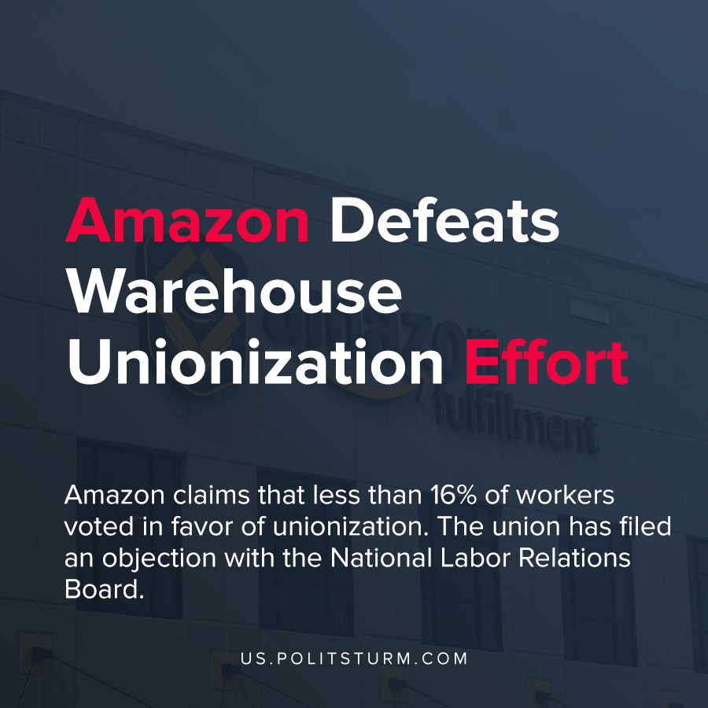

Original article
2021-04-10
1 min read

The Retail, Wholesale and Department Store Union (RWDSU) representing approximately 100,000 workers, filed a petition earlier this year to form a union at the Bessemer, Alabama Amazon location.
If a majority of the workers voted in favor of the union, the National Labor Relations Board would certify the union to collectively bargain on their behalf in negotiations with the company.
According to Amazon, less than 16% of the workers voted in favor of the union. The union is filing an objection with the National Labor Relations Board by citing the fact that the company “created an atmosphere of confusion, coercion and/or fear of reprisals and thus interfered with the employees’ freedom of choice.”
The tactics that Amazon employed according to the union include forcing employees to attend lectures with anti-union rhetoric and creating a misinformation campaign.
The capitalists are using all the tools at their disposal to ensure the maximization of profit and the protection of their class interests. As such, workers need to understand and apply Marxist theory to pose a threat to the capitalists who have endless resources to propagate the ideology and “logic” that justifies and continues their position as exploiters.
Source: 1 , 2 , 3

Original article

