Amazon Rainforest Cut Down to Accommodate COP30
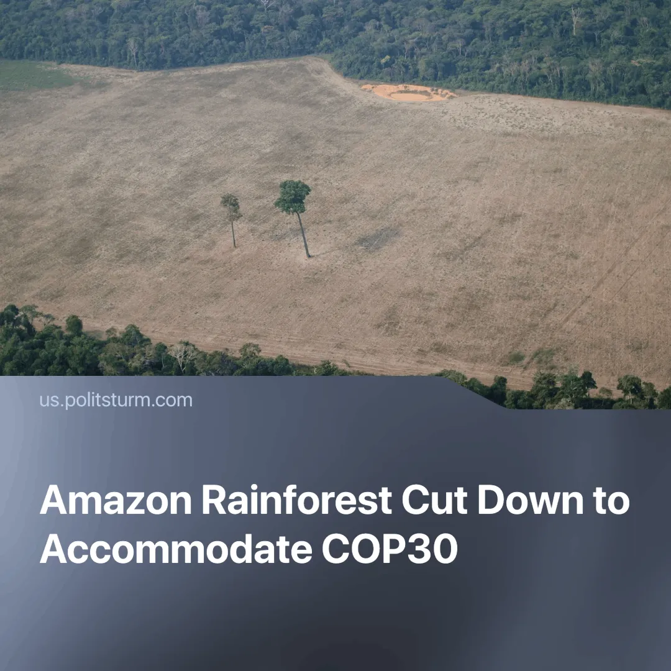

Original article
2025-03-17
2 min read

A new Brazilian motorway, the Avenida Liberdade, is being built in the state of Pará ahead of the COP30 climate summit. The four-lane motorway will cut through tens of thousands of hectares of protected Amazon rainforest to ease traffic.
Details. The next United Nations climate summit will be held in the city of Belém in November 2025. The city will host more than 50,000 people, including businessmen and government officials. The state has denied that the construction of the motorway is linked to COP30, but recent progress on the project would suggest otherwise.
► Alongside the highway project, the federal government is investing more than $81 million to expand the airport's capacity from "7 to 14 million passengers", along with other modernisation projects.
► The state government claims the construction will be done in a “sustainable” manner, but critics have pointed out its environmental impact on local wildlife and the livelihoods of those who depend on the forest —highlighting the irony of it happening just before COP30.
Context. Brazilian President Luiz Inácio Lula da Silva presents himself as taking the climate crisis seriously, often contrasting himself with his predecessor, whose tenure saw some of the most extensive deforestation in history.
► Lula has chosen this location for the climate summit because then it will be "a COP in the Amazon, not a COP about the Amazon".
► Climate change is a natural phenomenon, but the climate crisis is driven by human activity. The emission of "greenhouse gases" —greatly accelerated by the industrial revolution —traps heat in the Earth's atmosphere, causing average temperatures to rise beyond its natural fluctuations. This throws the Earth's delicate ecosystem out of balance.
Important to know. The Amazon rainforest plays an important role in slowing climate change. It acts as a 'sponge', absorbing harmful 'greenhouse gases', and is also home to a wide variety of living organisms, helping to maintain biodiversity.
► The felling of the forest before one of the most important climate summits, as well as Lula's reason for holding it within the Amazon, shows that under capitalism these events are mostly held "for show" to convince the rightly concerned masses "something is being done".
► The large gathering of businessmen and politicians from around the world also ends up facilitating deals between capitalists — even fossil fuel deals.
► The construction of the highway and general modernisation will also affect the local population. While some will benefit from increased trade and traffic, others who depend on the Amazon for their livelihoods will suffer, probably without compensation.
► The chaotic nature of capitalism, based on the pursuit of individual profit and competition, makes it fundamentally impossible to tackle the problem effectively. The immense wealth of those responsible for climate change also allows them to buy off leaders and scientists to protect their businesses.
Conclusion. Avenida Liberdade is a clear example of how capitalism continues to lead us into a global ecological disaster, even during the term of a supposedly "eco-friendly" leader. No matter how many times world leaders meet, global temperatures continue to rise and more and more people become negatively affected by the crisis. It is clear that the problem is our mode of production, with its unrelenting drive for profit through competition. What is needed is a planned economy that can consider the prosperity of the masses alongside sustainability, unhindered by big business or the profit motive. The real and only solution is socialism.

Original article

