Amazon CEO Pockets Billions As Workers Struggle to Survive
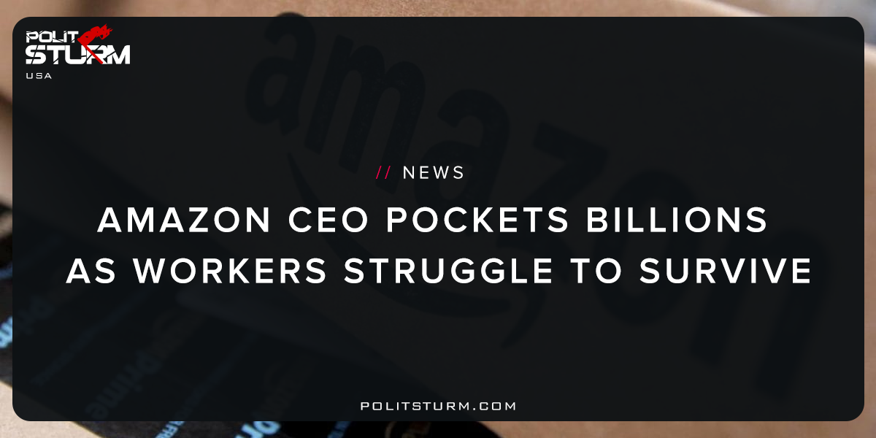

Original article
2018-01-29
2 min read

Jeff Bezos recently made headlines for becoming the world’s richest man. And after the launch of Amazon Go this week, Bezos tacked on another $2.8 billion to his net worth. But there’s another story that’s not getting as much attention.
Ten percent of Amazon‘s Ohio workforce is on food stamps, according to a snapshot study done by a nonprofit liberal-leaning policy research group called Policy Matters Ohio. And it was released just days before Bezos‘ net worth broke the world record at $105 billion.
The report looked at data from the Ohio Department of Job and Family Services. It found that roughly 700 employees, more than 1 in 10, at Amazon’s Ohio warehouses received SNAP benefits in August.
SNAP, or the Supplemental Nutrition Assistance Program, helps qualifying families purchase groceries through what’s commonly known as “food stamps.”
And it turns out, these Amazon employees relying on food assistance cannot use food stamps at the company’s new cashier-free store, Amazon Go, the company has confirmed to CNBC.
Politsturm: Reality often has the most damning condemnations of capitalism. The world’s wealthiest capitalist, Jeff Bezos, has added $2.8 billion to his net worth as the company stock increased 2.5%. At the same time 10% of Ohio workers are reliant on government assistance to put food on the table. The massive wealth that Bezos has accumulated, an estimated $116.2 billion, has been accumulated at the expense of the mass of working people who are still struggling to survive. There is no excuse, no justification, no conceivable rationality to explain this unfortunate situation. The only rationality for the capitalist is to accumulate ever larger sums of wealth no matter what the social consequences may be.
As long as the capitalist system exists, we will continue to have these disastrous and absurd results for the working class. There are no plagues, natural disasters, or famines that prevent the working class from feeding their families. Rather, the capitalist economic system constantly drives the living standards of the working class to the biological minimum. This exploitation of the working class undoubtedly increases the profits of the oligarchy, and so this situation persists. Capitalists like Bezos are not “job-creators”, “entrepreneurs” or other nonsensical terms created to paint a beautiful portrait of the exploiters. The fact that hard working Americans are not able to survive without government assistance shows the cruel, disgusting nature of the capitalist economic system and those who support it.
Sources: 1, 2, 3

Original article

