Air Force Delivers Payload of Baby Formula
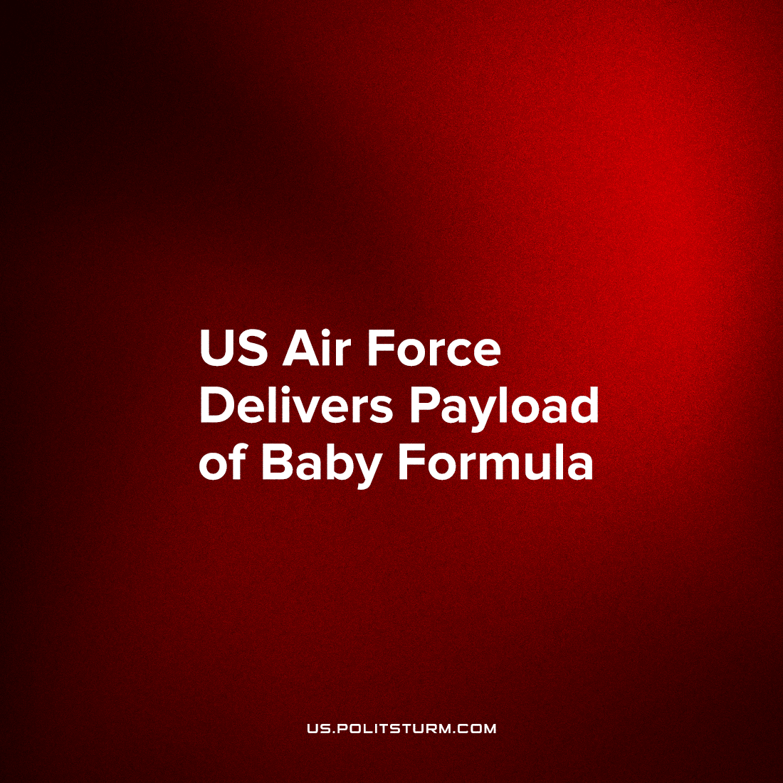

Original article
2022-05-27
2 min read

Biden declares “relief is on the way” as the second shipment of German baby formula lands in the U.S. today, and is sent to the Nestlé distribution center in Pennsylvania.
In partnership with monopoly corporation Nestlé, the President’s administration negotiated a temporary “enforcement discretion with respect to certain requirements for infant formulas that may not comply with certain statutory and regulatory requirements” from the FDA so that Nestlé products in the EU can be flown-in from Ramstein U.S. Air Force base in Germany, to mitigate the supply collapse created by the shutdown of the Abbott factory in Texas.
At the end of this program, 1.5 million baby bottles will be able to be filled from these Gerber shipments, which will be sent to hospitals, state nutrition programs, and commercial retailers.
But what draws most attention to this story is not the efficiency of the Biden administration in addressing a particular crisis, but the front-and-center role played in this solution by corporate-military cooperation.
US Airforce planes were requisitioned for use by Federal Express to transport the first shipment of 114 pallets of Nestlé specialty formula.
As we have pointed out from in our examination of the Marxist theory of Dmitrov;
A crucial element of fascism’s project for social cohesion is the militarization of the economy and of public life.
When the economic and political crisis deepens, it becomes more possible, more and more necessary, to intercede in the role of civilian labor. We have seen this trend emerging in recent years as National Guardsmen of numerous states were deployed to drive school buses in 2021, to undercut the rising expenses of employing the labor force.
Not only are the jobs of regular workers replaced with ‘emergency’ employment of military personnel, all this activity goes to fill the pockets of the corporate monopolies which both supply the formula and distribute it across the nation for profit. But while accomplishing this goal, the American state satisfies its need to have this program of corporate enrichment appear to be one of public service.
Despite the words of the smiling faces on TV, this program of relief is not meant to relieve Americans of this situation: as many commentators have pointed out, it cannot.
Obviously, it’s not a good sign for American workers that the world’s wealthiest nation needs ‘relief’, since relief fundamentally cannot guarantee security and regular access for working families. A program of relief, like the past program of cash hand-outs by the federal government, is a program for a non-solution to the problem, and reflects a deep inability of US capitalism to function normally to fulfill the needs of people in this economic crisis. This baby formula shortage is only one particular in a general economic insecurity felt by all Americans – while those with small children face greater anxiety and hardship.
Sources: 1 2 3 4

Original article

