Artificial Intelligence Multiplies the Wealth of Billionaires
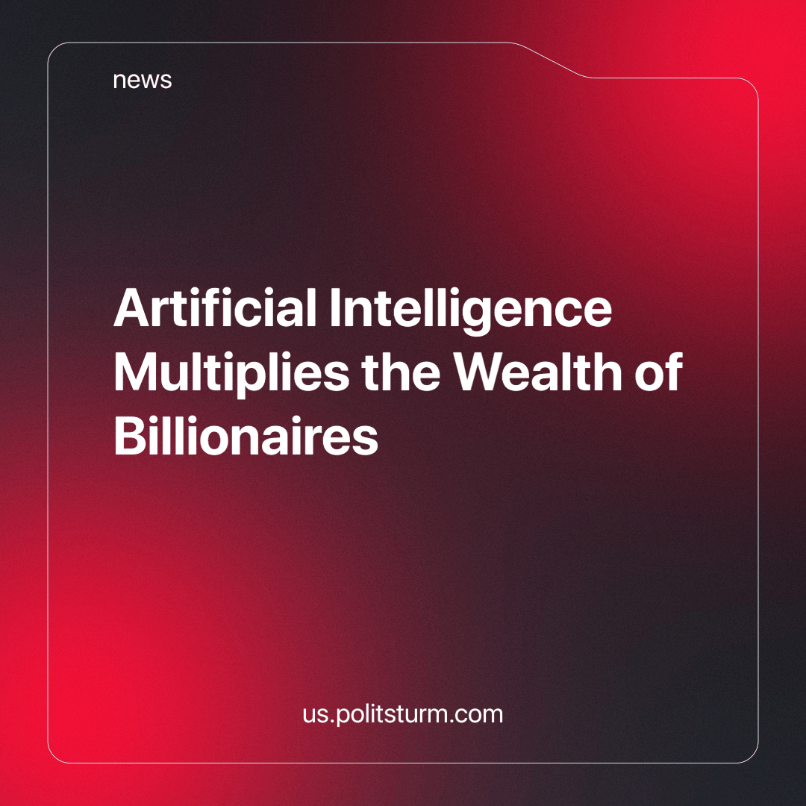

Original article
2024-02-07
2 min read

According to Bloomberg, in 2023, the collective fortune of the top 500 wealthiest individuals increased by $1.5 trillion. Technology business owners experienced the most substantial gains, with a 48% surge, totaling $658 billion, largely attributed to the rapid advancements in artificial intelligence.
Elon Musk claimed the title of the richest person in 2023, thanks to the success of Tesla and SpaceX, amassing an additional $95.4 billion. In second place, Jeff Bezos, the founder of Amazon, boosted his fortune by over $70 billion. Mark Zuckerberg, CEO of Meta Platforms Inc.*, secured the third position, accumulating more than $80 billion in a year.
Notably, Nvidia Corp. emerged as the most financially successful company, witnessing a remarkable 230% increase in its fortune in 2023. The company is also projected to generate around $48 billion in profit over the next 12 months, surpassing initial forecasts of $10 billion at the beginning of the year.
Several other major companies, including Apple Inc., Microsoft Corp., Alphabet Inc., Amazon.com Inc., Nvidia, Meta Platforms Inc.*, and Tesla Inc., attracted investors eager to capitalize on artificial intelligence.
Russian billionaires also experienced a notable wealth increase, totaling $38.5 billion since the start of the year, according to RIA Novosti news agency using data from the Bloomberg Billionaires Index (calculated based on the share price of companies in which billionaires have invested). Vagit Alekperov, co-owner of Lukoil, saw the most significant increase, with his fortune rising by $9.14 billion to $24.5 billion. Remarkably, among the 110 Russian billionaires on the Forbes list, only 13 experienced a decrease in wealth in 2023.
Year over year, the song remains the same - the rich, still getting richer and the working class is left to fight over the breadcrumbs that fall to us. While capitalists are amassing billions of dollars in profits, the working class, which is exploited for those same profits, are being drowned by heavy debts, and are only a few fragile steps from homelessness. Only by ripping the means of production from the capitalists' hands, by working-class hands, can give us the control we need to determine our own future.
*Meta Platforms Inc. recognized in Russia as an extremist organization and banned.
Source: Central trade union newspaper "Solidarity" - “Artificial intelligence has enriched billionaires” from December 29, 2023

Original article

