Major Attention Disorder Medication Shortage
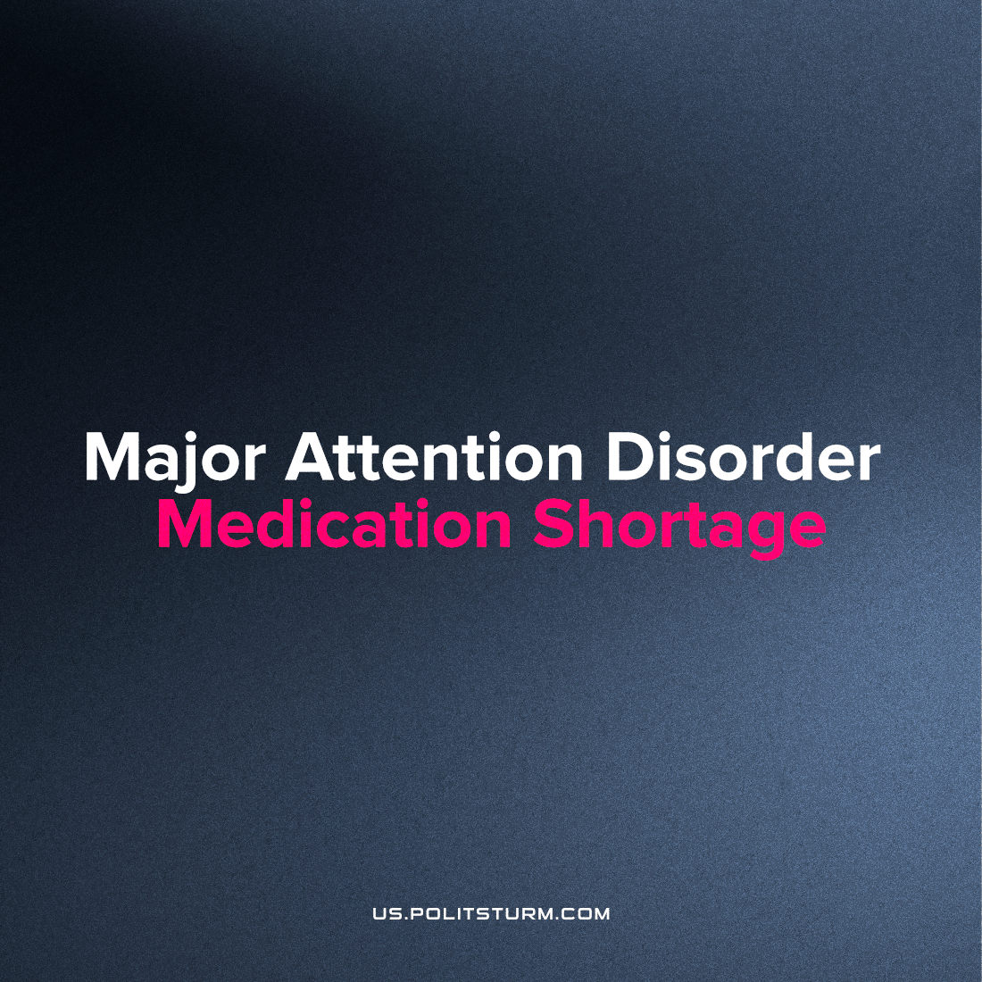

Original article
2023-02-09
3 min read

Problems with the supply of ADHD drugs that began in the summer of 2022 have not yet been resolved, millions of Americans are at risk of facing a shortage.
The problem became known in November[1], when due to production problems at the largest manufacturer of Adderall in the USA, Teva Pharmaceuticals and increased demand in 2022 began to observe a shortage. The problem was that employees quit due to low salaries and Teva was unable to maintain the required level of production. As Teva reported, by December 2022 the entire deficit will be eliminated, as they still managed to recruit workers and launch their production facilities to the previous level... but reality shows the opposite[2].
According to the Food and Drug Administration (FDA), the shortage is caused by a labor shortage at Teva Pharmaceuticals, one of the main manufacturers of Adderall.
The shortage also affects other manufacturers. For example, Sandoz, another pharmaceutical manufacturer, was unable to meet customer requests for orders of generic long-acting drugs. The American Society of Health-System Pharmacists, reported shortages affecting nearly 40 variations [3] of the generic drug in Ritalin - the other prescribed treatment for attention disorders.
Teva was also affected by supply issues. The company reported unfulfilled orders for mixed amphetamine salts, which are the main ingredient of Adderall. It also experiences periodic production delays which disrupt in the supply chain[4].

What are the true causes for the shortage?
1. Increasing demand, the quota industry does not allow other companies to produce in excess of their quota.
Adderall is a controlled substance, so patients are required to obtain a doctor's prescription. Subject to strict regulation, manufacturers have an annual limit on the amount of the drug they can sell. This also means that it is prohibited from being sold by other companies. [5]
Recently, the demand for the drug has increased dramatically, as more people are diagnosed with ADHD. At the same time, diagnosis under capitalism is bound up with the market relationship between pharmaceutical corporations and medical service providers, leading to serious problems with over-issuance of prescriptions. (Read our article on capitalism's promotion of drug abuse)
2. Shortage of labor at the largest manufacturer Teva Pharmaceuticals, indelibly tied to their refusal to increase wages.
3. Lack of supply of raw materials, observed at Teva and the manufacturer Sandoz, which supply an analogue of Adderall - generic drug of prolonged action.
4. The inability to effectively redistribute resources under the capitalist system. The market for these medicines is strictly regulated and the state, as proteges of the bourgeoisie, will not share profits for the sake of the well-being of its citizens. Although there is still an opportunity to meet demand by increasing the quota for imported medicines.

What does the Drug Enforcement Administration (DEA) report about this situation?
DEA determined that the proposed quotes for amphetamine, dexmethylphenidate, methylphenidate, and lisdexamfetamine are sufficient to supply legitimate medical needs, reserve stocks, and export requirements for 2023.
DEA is aware of patient reports that pharmacies are unable to fill prescriptions for their prescribed Adderall or one of its generic versions. The majority of the manufacturers contacted by DEA and/or FDA have responded that they currently have sufficient quota to meet their contracted production quantities for legitimate patient medical needs. According to DEA's data, manufacturers have not fully utilized the annual limit for amphetamine in support of domestic manufacturing, reserve stocks, and export requirements for the past three calendar years 2020, 2021 and 2022.[5]
So, based on their response to the complaints of suffering patients, we understand that either manufacturers intentionally create a shortage, or the government brazenly deceives and blames the producers.
Due to the fact that capitalists are saving on workers’ salaries, there was a downtime of production capacities in August 2022, which overlapped with increased demand this fall and winter. which led to a shortage of medicines. Capitalism once again shows its true face, by causing shortages of basic medicines as a result of its regular economic cycles in which that the main thing is the profit of invested capitalists, not the health of millions.
The state, as a regulator, which is supposedly obliged to protect ordinary American workers from unscrupulous companies, actually protects the profits of companies, reporting that they are not going to raise quotas to meet demand yet, and even more so to increase the quota of imported medicines... because it is unprofitable for American manufacturers like Teva. “The market shares are divided and the main thing is our money made from your diseases,” the ruling class of America tells us.
Sources: 1, 2, 3, 4, 5

Original article

