Lenin on Religion
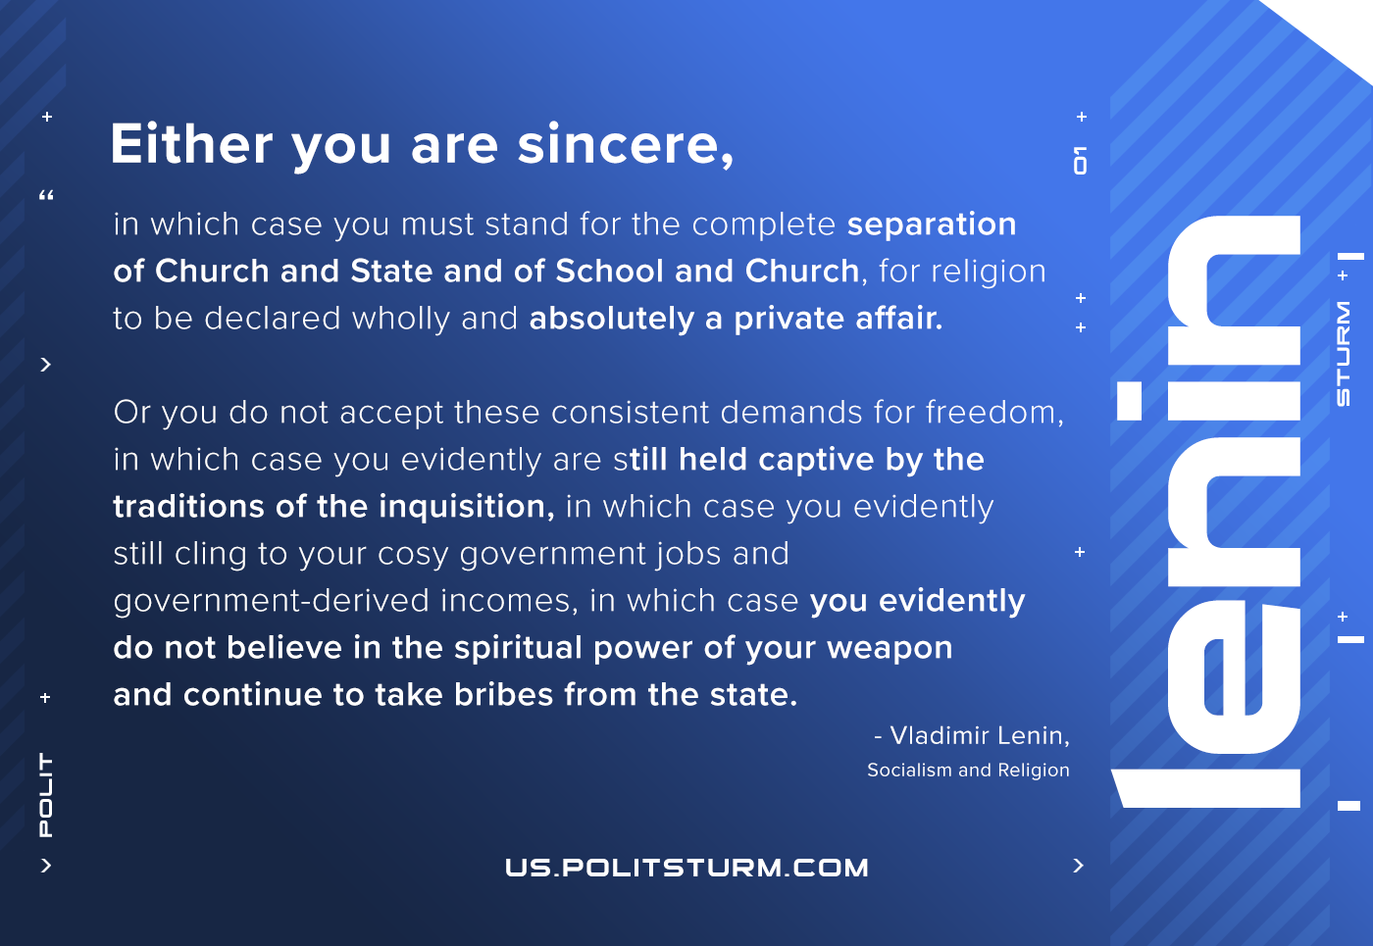

Original article
2021-02-24
1 min read

Either you are sincere, in which case you must stand for the complete separation of Church and State and of School and Church, for religion to be declared wholly and absolutely a private affair. Or you do not accept these consistent demands for freedom, in which case you evidently are still held captive by the traditions of the inquisition, in which case you evidently still cling to your cosy government jobs and government-derived incomes, in which case you evidently do not believe in the spiritual power of your weapon and continue to take bribes from the state.
Lenin, Socialism and Religion

Original article

