8 Million Americans Have Fallen Into Poverty Since May
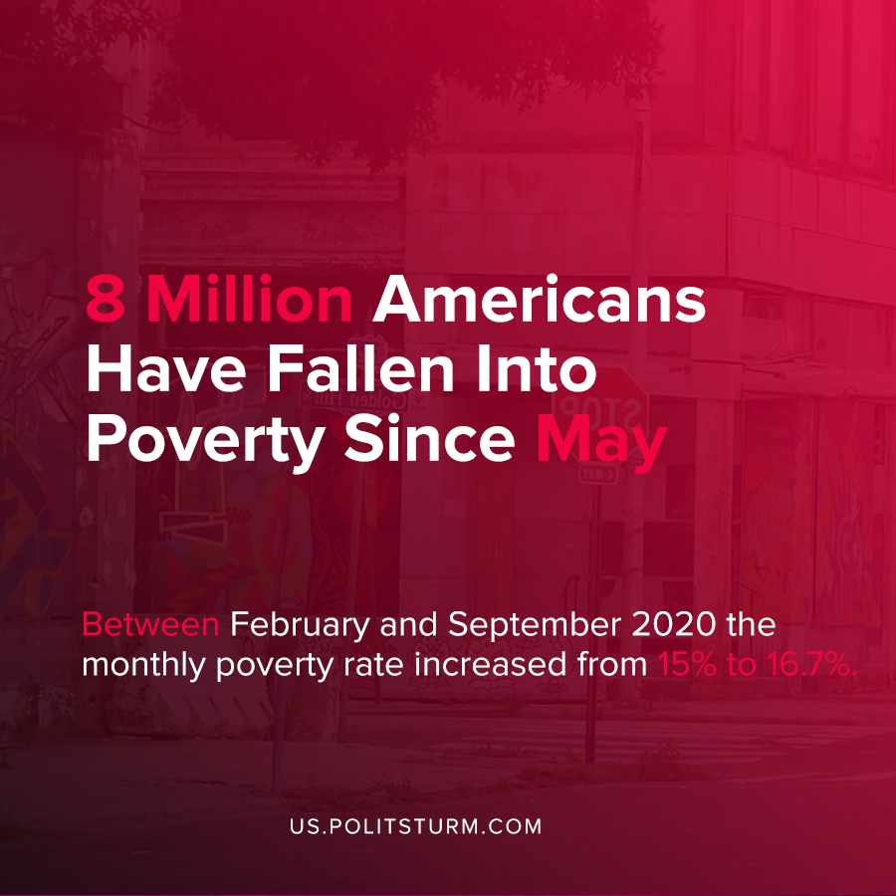

Original article
2020-10-17
1 min read

A new study published by researchers at Columbia University found that 8 million more Americans have fallen below the poverty line since May 2020. Between February and September 2020 the monthly poverty rate increased from 15% to 16.7%.
Following the onset of the more recent capitalist crisis and the accompanying coronavirus pandemic, the CARES Act was passed which had provisions for stimulus payments as well as a $600 per week unemployment supplement.
The unemployment supplement expired at the end of July, which according to the authors “contributed to an increase in poverty rates in August and September”.
While the study exceptionally describes the current poverty that afflicts millions of Americans during the latest crisis, there is not one mention of the root cause: capitalism.
The disruption caused by the economic crisis and pandemic are shaped by the current economic formation, capitalism, which is predicated on maximum profitability. As business activity shuttered millions of Americans lost their incomes and without the temporary support enacted through the legislature they became impoverished.
Only the replacement of capitalism by socialism will be able to fundamentally eliminate the problem of poverty and not simply describe its social implications.
Source: 1

Original article

