Congress Authorizes Creation of Labor Caucus
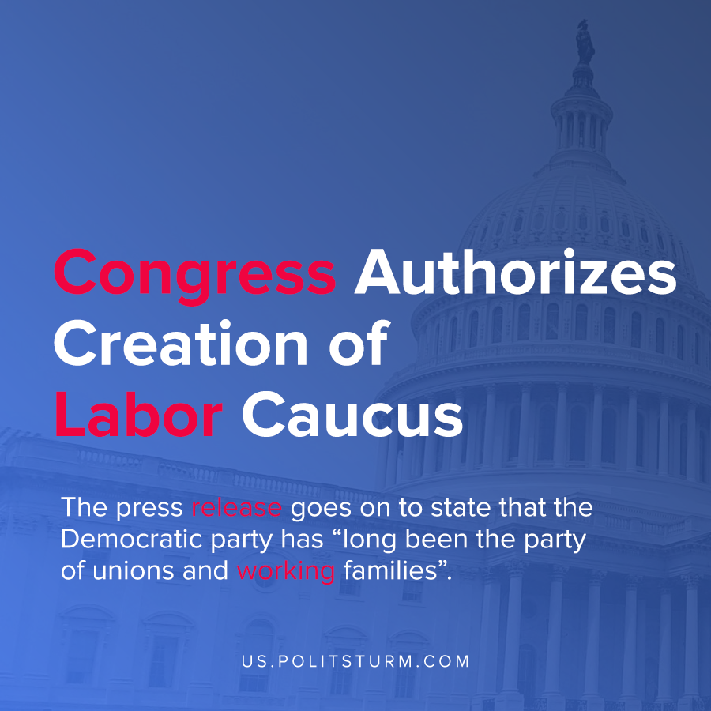

Original article
2020-11-26
1 min read

Congressional representatives Mark Pocan and Donald Norcross announced the formation of the Labor Caucus to “advance the needs of the labor movement, combat the issues facing working families, and connect legislators directly with unions and union leaders”.
In a press release announcing the caucus, it is stated that the Presidency of Donald Trump has eroded labor rights and a revitalization of labor rights under the Biden presidency is to be expected.
The press release goes on to state that the Democratic party has been the party that represents the interests of the workers and unions. However, regardless of whether a Democrat of Republican has held office the position of unions and the objective conditions that working class families face have declined.
For example, the unionization rate in the United States has declined from 20.1% in 1983 to 10.3% by the end of 2019. The rate of unionized workers has almost been cut in half over the administrations of both Democrats and Republicans while the wealth of the billionaires has soared.
A logical explanation for the aforementioned objective results is that both parties represent the interests of the capitalist class. While the Democrats claim to support workers, their support is only relative to the Republican party who unabashedly serve the interests of the oligarchs.
While the unionization rate is only one measure of the strength of the working class in the United States, there are countless metrics which show the declining position of the working class who have no political party to represent their class interests. Only a party based upon the principles of Marxism-Leninism can truly serve the interests of the workers, not only rhetorically but in practice and by achieving tangible results.
Source: 1 , 2 , 3

Original article

