75% of Workers Risk Increased COVID Exposure at Work
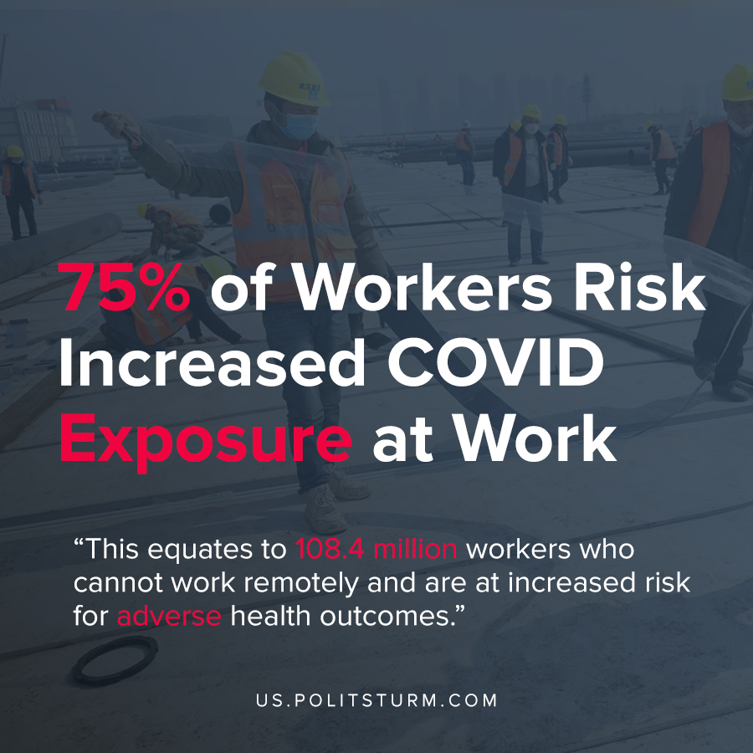

Original article
2020-07-01
1 min read

According to new study by University of Washington researcher Marissa Baker, 75% of U.S. workers work in occupations that cannot be performed remotely and are at increased risk during a pandemic. These workers work in health care, manufacturing, retail, food services, and other jobs which are challenging or impossible to complete from home. This equates to 108.4 million workers who cannot work remotely.
The remaining 25% of workers perform work that can be done remotely including technology, finance, administrative services, and engineering.
“When access to a workplace is restricted because of a public health emergency, the workers who cannot work from home are likely to experience job disruption, hours reduction, or voluntary or involuntary layoff”, said Baker in the study.
Workers who are exposed to the aforementioned negative consequences can experience negative physical and mental side effects. These outcomes include suicide, depression, stress, changes in diet, and physical incomes like coronary heart disease.
Thus, during the coronavirus pandemic a large number of American workers suffer from a wide array of physical and mental consequences. In the United States, workers who are reliant upon their jobs for health insurance suffer from unemployment or underemployment when they need access to healthcare the most, during a pandemic.
This situation also causes undue mental and physical complications that fall upon the lowest paid and most vulnerable workers. Whereas the socialist organization of production would protect the interests of the working class as a whole, the capitalist organization serves the interests of the capitalists while the workers suffer from the negative consequences.
Source: 1

Original article

