75% of Undocumented Immigrants Doing Critical Work During Pandemic
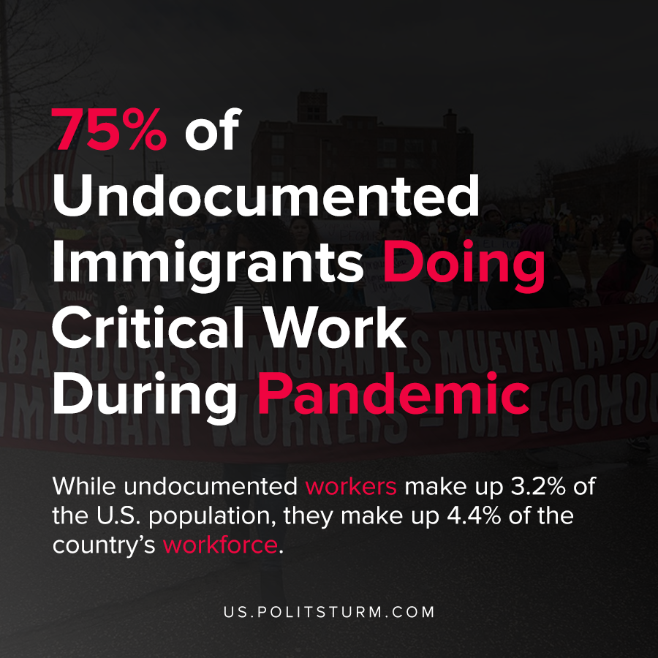

Original article
2020-12-03
1 min read

According to research by the Center for American Progress, undocumented immigrants are working in jobs that are critical during the coronavirus pandemic. While undocumented workers make up 3.2% of the U.S. population, they make up 4.4% of the country’s workforce.
These workers are doing work in critical sectors of the economy such as construction, agricultural work, cooking and cleaning. In fact, almost 3 out of 4 undocumented workers are doing work critical to the functioning of the economy during the ongoing pandemic.
The report raises questions about the difference between the contributions that these workers make to American society, and the way they are treated.
“Undocumented immigrants are simultaneously vulnerable to being coerced into accepting dangerous work situations and may be among the first workers to be laid off, particularly if they raise concerns”, the report says.
The capitalist class benefits from the employment of undocumented workers due to the enormous value they create in the economy. Simultaneously, capitalist society ruthlessly exploits these workers and the capitalist government denies them benefits such as Medicaid, healthcare subsidies, the Supplemental Nutrition Assistance Program (SNAP), etc.
The capitalist economic system is predicated upon the exploitation of these workers all to benefit the class of oligarchic billionaires.
Sources: 1 , 2

Original article

