73% of Disneyland Workers Struggle to Make Ends Meet
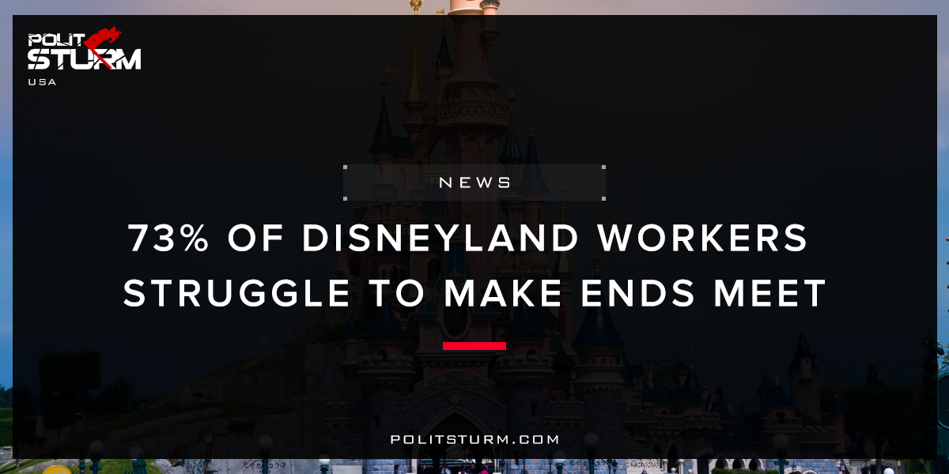

Original article
2018-03-02
2 min read

Disneyland employees report high instances of homelessness, food insecurity, ever-shifting work schedules, extra-long commutes, and low wages. While there is national attention on the minimum wage and have been successful local efforts to raise the minimum wage to $15 an hour, more than 85% of Disneyland workers earn less than $15 an hour. Notwithstanding their economic hardships, more than three-quarters (80%) of employees say they are “proud of the work I do at the Disneyland Resort.
The average hourly wage for Disneyland Resort workers in real dollars dropped 15% from 2000 to 2017, from $15.80 to $13.36. Almost three-quarters (73%) say that they do not earn enough money to cover basic expenses every month. Disneyland employees worry about keeping a roof over their heads. Over half (56%) of Disneyland Resort employees report concerns about being evicted from their homes or apartments. More than one out of ten (11%) Disneyland Resort employees – including 13% of employees with young children – report having been homeless – or not having a place of their own place to sleep – in the past two years. Over half (52%) of workers who rent their housing are overcrowded – squeezing too many family members, roommates or even multiple families into a unit that is too small to accommodate the number of occupants.
Politsturm: It is extremely sad that workers at the “happiest place on Earth” suffer from such deplorable working conditions and pay. 85% of the workers at Disneyland earn less than $15 per hour. These are the people who work hard to make others happy and make Disneyland a reality. It is completely absurd that these people are struggling to survive while at the same time Disney has $1.256 billion in free cash as of Q4 2017. To add insult to injury, Disney mentions a $1.6 billion one-time net tax benefit from the “Tax Cuts and Jobs Act”.
Capitalism is not able to provide stable employment, housing, and education to the working class. The capitalist system is driven by the insatiable lust for profit. The capitalist class benefits from the suppression of wages, benefits, and inhumane working conditions. Capitalists are able to squeeze the working class for profits. These profits are then distributed to capitalists and landlords in the form of dividends, interest, and rent. As long as the capitalist economic system exists this legalized theft will persist.

Sources: 1, 2

Original article

