72% of Hungarians say country worse off under capitalism
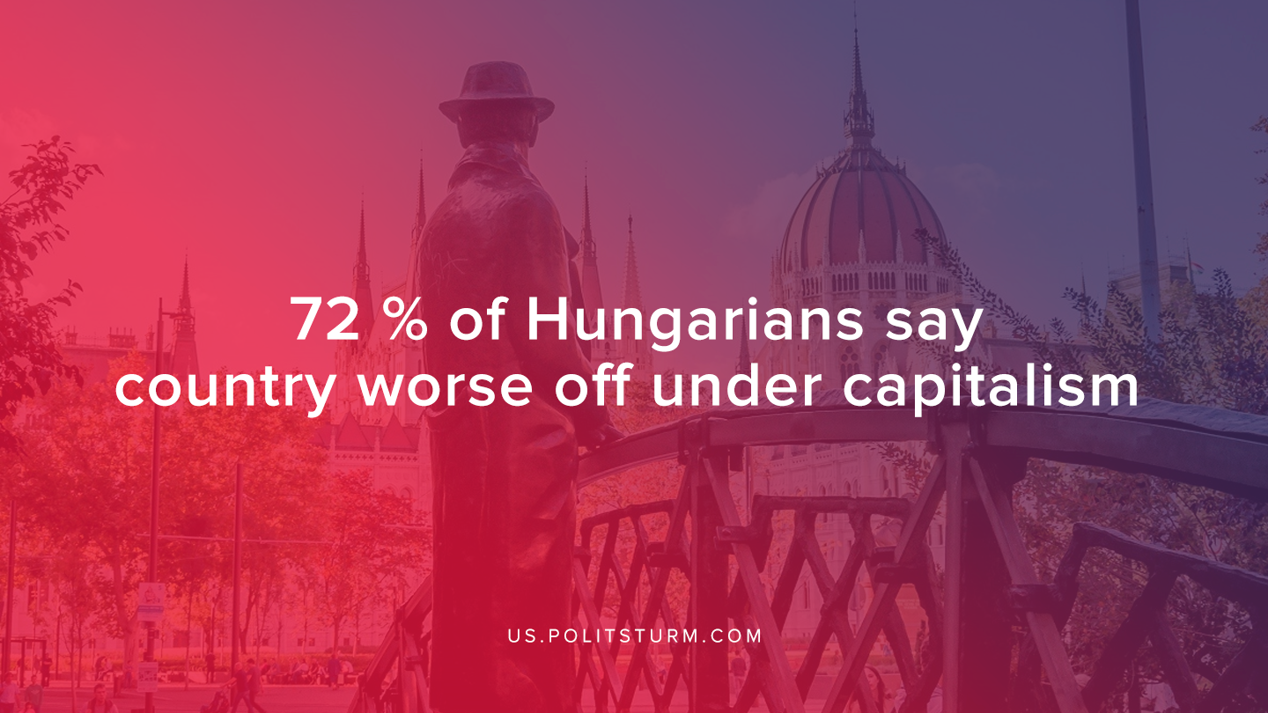

Original article
2019-12-21
1 min read

Ever since the collapse of the Warsaw pact, an enormous step back had occurred and the people from the socialist block that thought welfare will always stay with them were tremendously disappointed. Such disappointment from the capitalist system emerged in Hungary.
“A remarkable 72% of Hungarians say that most people in their country are actually worse off today economically than they were under communism.”
“Fully 94% describe the country’s economy as bad, the highest level of economic discontent in the hard hit region of Central and Eastern Europe. “
Like many others, the Hungarian proletariat permitted the success of reactionary forces and now are forced to survive, rather than live. Upon privatizing their industry, the guarantee for work swiftly ended since the Indian and African proletariat can be exploited far easier. The Hungarian economy is remaining stagnant showing no prospects for the Hungarian people. People will have further doubt in the capitalist system. This will only radicalize people, however, through empty lies people will see hope in nationalists. They will unite people against foreign capitalists and work with theirs, while the exploitation will further prevail. The only solution is socialism. No nationalist, liberal nor social democrat will resolve the crisis of capitalism, as they function to retain in and continue feeding empty promises of prosperity from capitalism. But the barrel organ can only spin for so long until it breaks, and once it does, it will spill out in a revolution. A revolution for liberation, the liberation of mankind, under only one flag, the flag of the hammer and sickle.
Source

Original article

