66% of JetBlue Flight Attendants Vote To Join Union
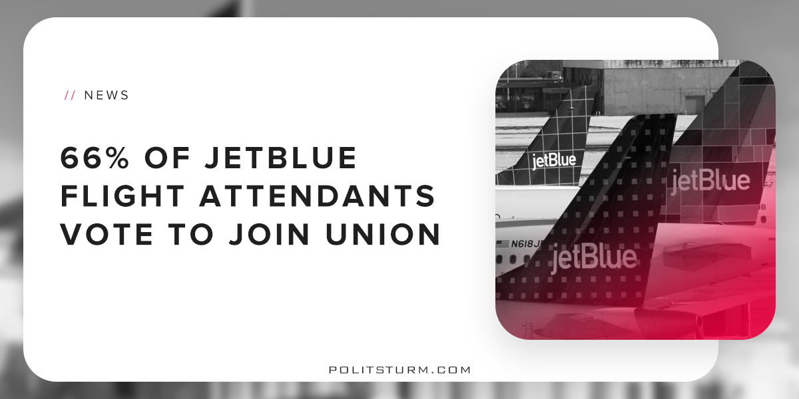

Original article
2018-07-30
1 min read

In their most recent annual report, the airline company JetBlue stated that their goal is achieving “superior margins”, which it defines as profit margins consistent with its competitors. In order to achieve this objective, the corporation is now laying off employees through “corporate restructuring” in order to achieve a $300 million annual reduction in costs by 2020.
Earlier this year, 66% of JetBlue flight attendants voted to join the Transport Workers Union of America (TWU). JetBlue announced that it was “disappointed” with the decision for workers to unionize. The Transport Workers Union stated that it’s priorities in contract negotiations are fighting for increased wages and benefits, job security, among other demands.
JetBlue stated publicly in their shareholder reports, which are distributed annually to stockholders, that the unionization could lead to increased labor costs and reduced efficiency.
This means that if the unionized workers are able to fight for increased wages and benefits, this will reduce the amount of profit available for shareholders. From the standpoint of the capitalist class, increased wages and benefits are “inefficient” because this money could otherwise be funneled off to investors.
The capitalist system is riddled with contradictions, but one of the most obvious is the opposition of capital and labor. A small group of oligarchs have been tirelessly working to destroy unions, undermine public benefits, and destroy all barriers to capital.
With unionization rates at a historic low, the workers in the United States are starting to fight back. The capitalist class is not interested or concerned with the welfare of the working class beyond its ability to produce profit for investors. The flight attendants of JetBlue voted in accordance with their class interests, which caused corporate executives to express their deep disappointment.
https://www.forbes.com/sites/tedreed/2018/04/17/jetblue-flight-attendants-vote-to-join-transport-workers-union/#d9402542464e
http://blueir.investproductions.com/~/media/Files/J/Jetblue-IR-V2/Annual-Reports/jetblue-2017-annual-report.pdf
https://www.cnbc.com/2018/07/20/jetblue-reshuffles-corporate-headquarters-braces-workers-for-layoffs.html
http://www.twu.org/twu-international-president-john-samuelsen-statement-on-the-historic-jetblue-flight-attendant-vote-for-representation/

Original article

