52% of Americans Worried About Receiving Medical Care Due to Understaffing
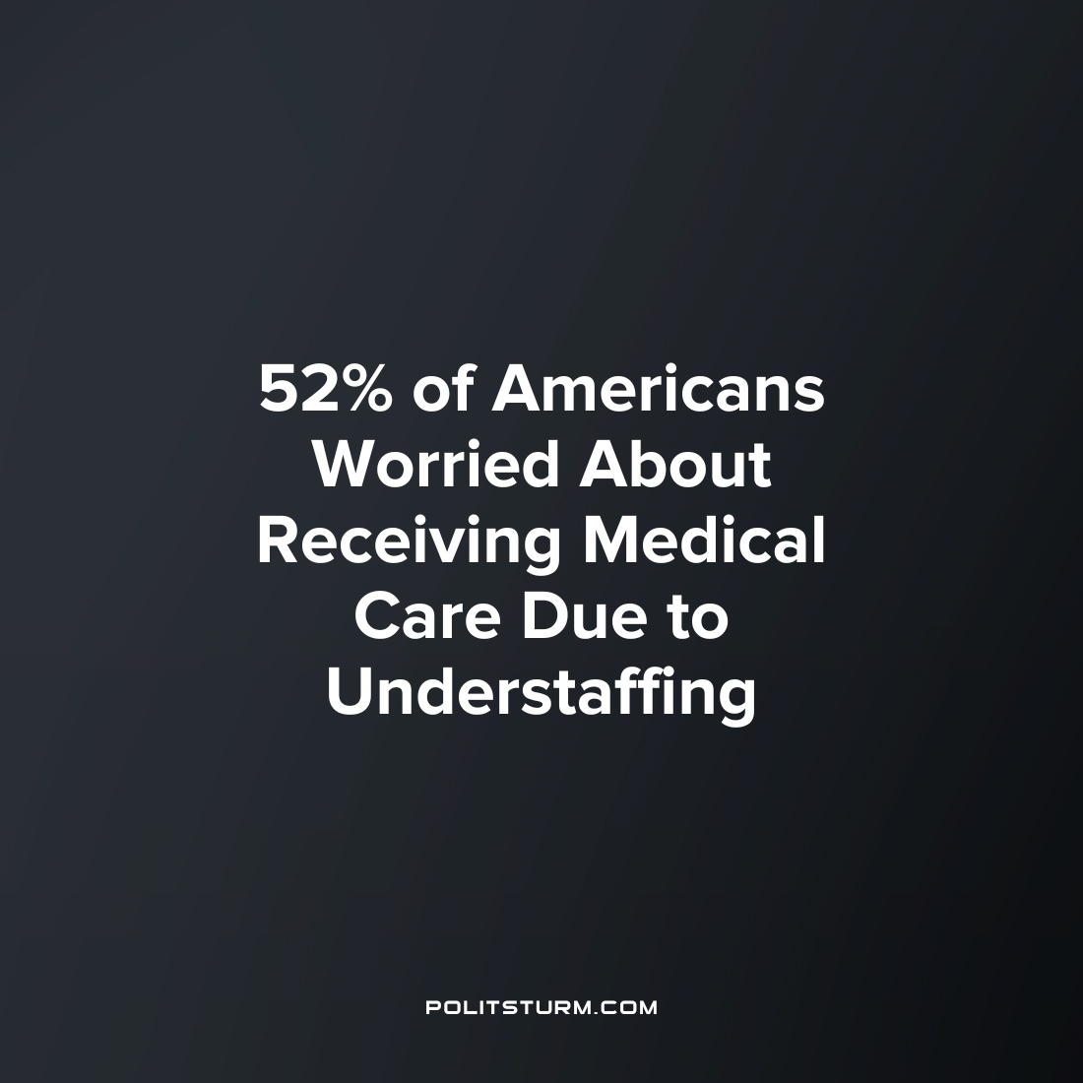

Original article
2023-04-24
1 min read

A recent poll released by HealthDay/Harris Poll finds that a large percentage of Americans are concerned with understaffing in the health care sector. 52% of the poll participants were worried that they would not be able to get medical care if needed due to the conditions of understaffing in hospitals.
84% of American adults have tried to get medical care in the past six months and 73% of the respondents experienced delays.
HHS data from 2022 found that 19% of U.S. hospitals were critically understaffed based on the hospital's internal policies for staffing ratios.
The results are unsurprising as the profit-driven organization of health care is primarily geared towards the maximization of profit and not towards providing the highest possible level of health. Profit maximization implies the maximization of revenue subject to the costs which include the employment of labor. Thus the anxiety surrounding healthcare staffing is justified because hospitals will be staffed to the extent necessary to maximize profits which is not necessarily a level which will meet the needs of the masses. As always, the capitalist system puts the profit of the oligarchs above the needs of the majority of workers.
Sources: 1 2

Original article

