50% Of American Millennials Support
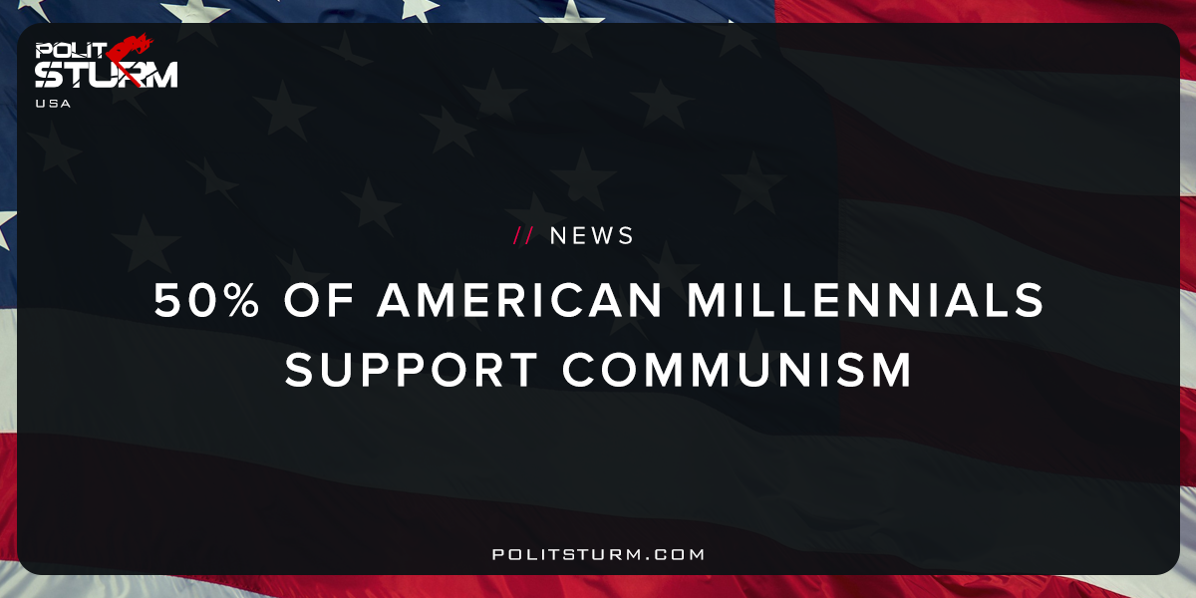

Original article
2017-11-03
1 min read

“According to the latest survey from the Victims of Communism Memorial Foundation, a D.C.-based nonprofit, one in two U.S. millennials say they would rather live in a socialist or communist country than a capitalist democracy.
What’s more, 22% of them have a favorable view of Karl Marx and a surprising number see Joseph Stalin and Kim Jong Un as “heroes.””
Politsturm: As capitalism fails to provide American youth with the prospects for a better future, they are turning sharply towards Communism. Despite the propaganda campaigns initiated by outlets such as the “Victims of Communism Memorial Foundation” , Americans are rejecting capitalism. The reason for this is quite simple. Capitalism as an economic system is unstable, exploitative, and environmentally destructive. Communism provides employment, rational organization of production, and sustainability. Capitalism is failing on its own volition due to its internal contradictions. American working people are exerting more effort to enrich the parasitic capitalists who live off the life-blood of the working class. It is fortunate to see that American millennials are turning toward socialism which supports democracy, equality, and freedom for the working class.
Source

Original article

