40% of German Companies Expect Recession in 2023
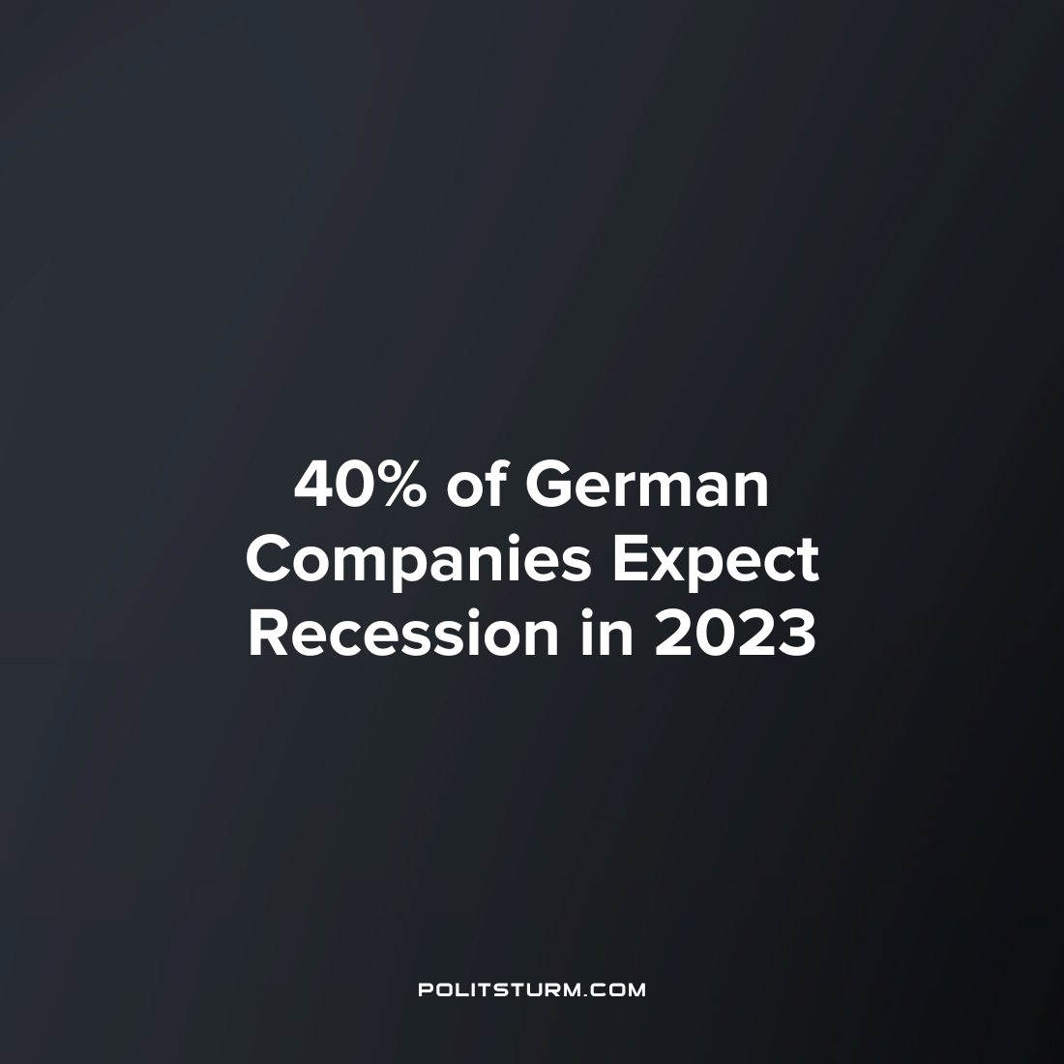

Original article
2023-01-26
1 min read

According to the German Economic Institute study (Institut der deutschen Wirtschaft - IW), 40% of the 2,500 German companies surveyed expect a business recession in 2023. Another 35% predict economic stagnation. Only a quarter of the surveyed companies expect business expansion in the coming year.
The most pessimistic expectations are in the construction sector. 54% of companies predict a recession, while only 15% expect business growth in 2023. In the industrial sector, the prospects look a little better, but still not promising – with only 28% of industrial enterprises forecasting growth, while 40% expect a decline.
It is noteworthy that only 32% of the surveyed companies assess their current economic situation to be better than a year ago. Those who believe that the financial situation of their enterprises has deteriorated over the past year, many blame rising electricity prices, increased interest rates and persistent difficulties with the raw materials supply as the reasons for business interruptions last year.
It is not difficult to guess which companies have the best economic prospects for 2023. Even without knowing the specific companies surveyed by IW, it can be assumed with a significant degree of confidence that the largest corporations with monopolies in the market are most likely to forecast growth.
This is the law of capitalism – big business continues to get richer at the expense of smaller competitors. At the same time, the gap between the economic elite and the rest of the population is growing especially rapidly during the crisis. As a result of the business recession and increasing economic difficulties, a significant part of small owners will be forced to close their business and join the working class ranks.
The situation in Germany clearly shows these trends. The capitalist system contributes to the further enrichment of the small group of large and richest owners and leads to the impoverishment of the working majority. The only correct way to get out of this situation lies not in reformation of the capitalist system, but in its replacement with a socialist system.
Source:
Finanzen.net – “40 Prozent der deutschen Unternehmen rechnen für 2023 mit Rezession“ from January 9, 2023.

Original article

