35 Detained at Fascist Demonstration in Oslo
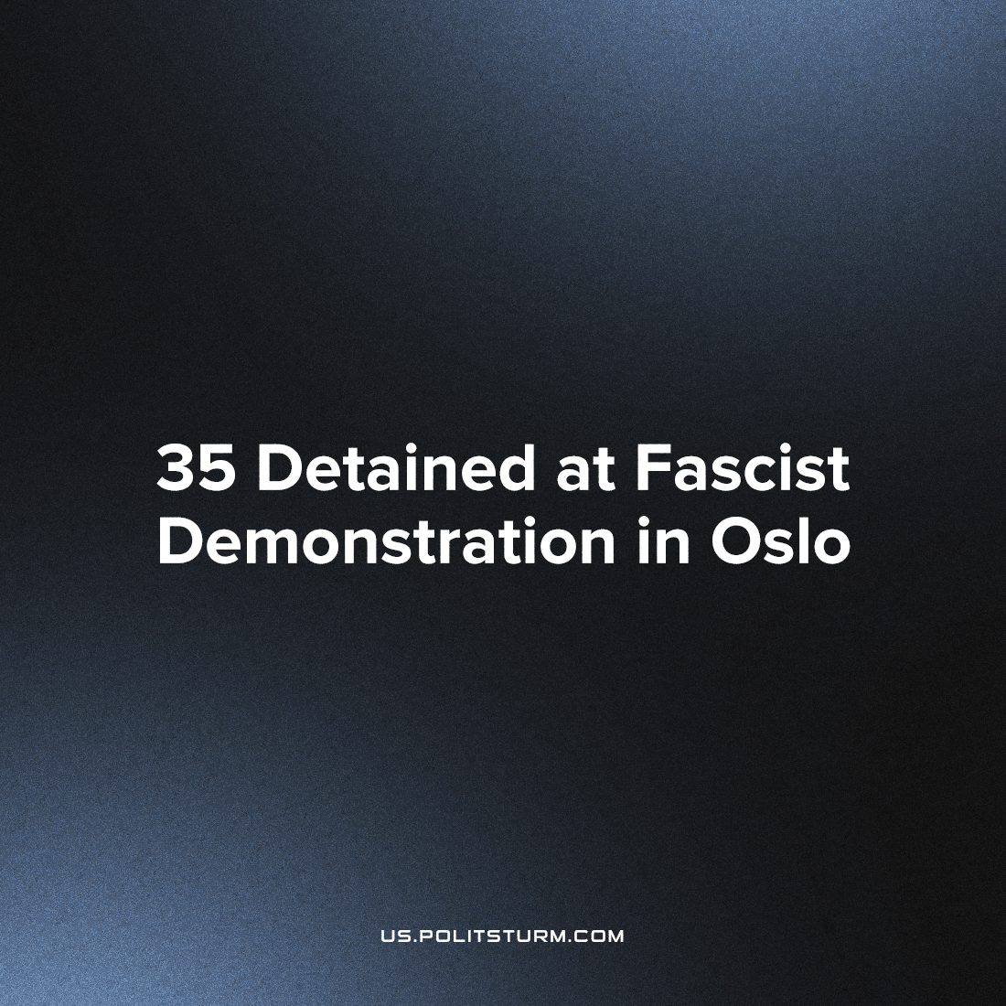

Original article
2022-11-10
1 min read

On Saturday, October 29th, Scandinavian neo-Nazis from “The Nordic Resistance Movement” held a demonstration outside the parliament building in Oslo, Norway. During the demonstration, clashes broke out between demonstrators and policemen. As a result, 35 people were detained.
According to local law enforcement agencies, all but four detainees are foreign citizens. It turned out that most of them are citizens of Sweden; others having citizenship in Denmark. The court decided all arrested would be fined for attacking police officers, and the foreign citizens would be deported from Norway.
Founded in 1997, the Nordic Resistance Movement aims to create a Nordic National-Socialist Union consisting of Sweden, Norway, Denmark, Finland and Iceland. Some members rally for the inclusion of the Baltic countries in the union.
The Northern Resistance Movement is one of the neo-Nazi organizations that has recently gained popularity. Taking advantage of the current crisis and the people’s desperation, these groups propose to unite the local population around their myth of racial superiority and blame the economic problems on the spectre of an external enemy – usually migrants of foreign origin.
In fact, these fascists only worsen the position of the working class. By dividing the workers along racial or other lines, the fascists distract them from the fight against the real enemy – capital. Only through the class struggle against capital can the working class finally end economic crises and establish a decent standard of living for everyone.
Source: 1, 2, 3

Original article

