Trump Attacks Communism at UN Convention
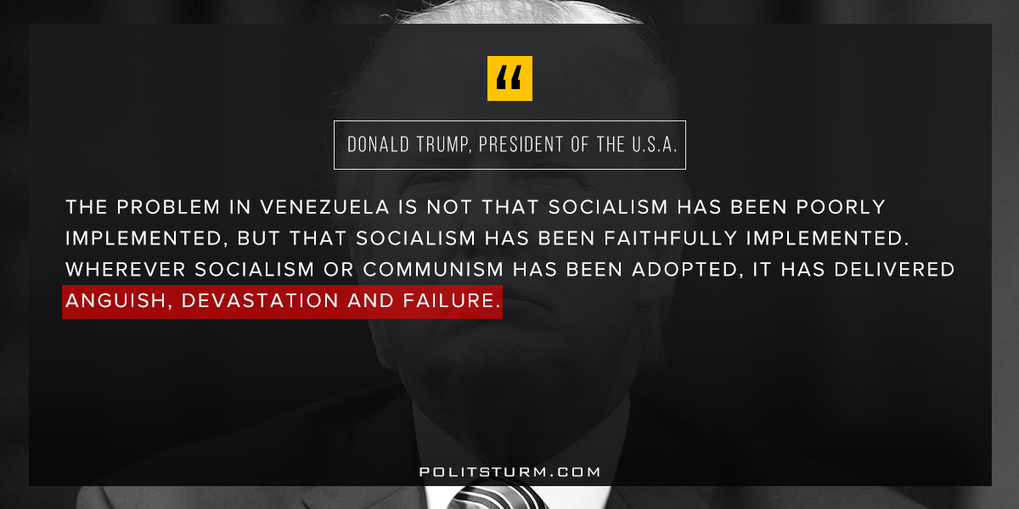

Original article
2017-09-21
1 min read

For listeners old enough to remember the Soviet Union, President Donald Trump’s address to the UN General Assembly echoed some of the old thunder of Cold War hostility.
Taunting “Rocket Man” Kim Jong Un, whose rogue dictatorship has Marxist-Leninist vestiges, Trump warned of North Korea’s utter destruction if necessary.
The American president’s warning to Nicolas Maduro of Venezuela had a more distinct ideological flavor.
“The problem in Venezuela is not that socialism has been poorly implemented, but that socialism has been faithfully implemented,” Trump said.
“Wherever socialism or communism has been adopted, it has delivered anguish, devastation and failure.”
Politsturm: This is just the latest example of anti-communist propaganda coming this time from President Trump. The bourgeois class in America is certainly aware of the deteriorating social, economic and political conditions in the U.S. In order to maintain power, the media and political figures resort to attacking Venezuela and North Korea as a form of distraction. While this may be politically convenient, this rhetoric does not convince well-informed Americans. The deterioration we are experiencing is not because of socialism, but rather is the result of the declining world capitalist system. The “anguish, devastation, and failure” is our own and is the result of our irrational, anarchic economic system: capitalism.
Source

Original article

