31% of Re-Hired Workers Laid Off Again
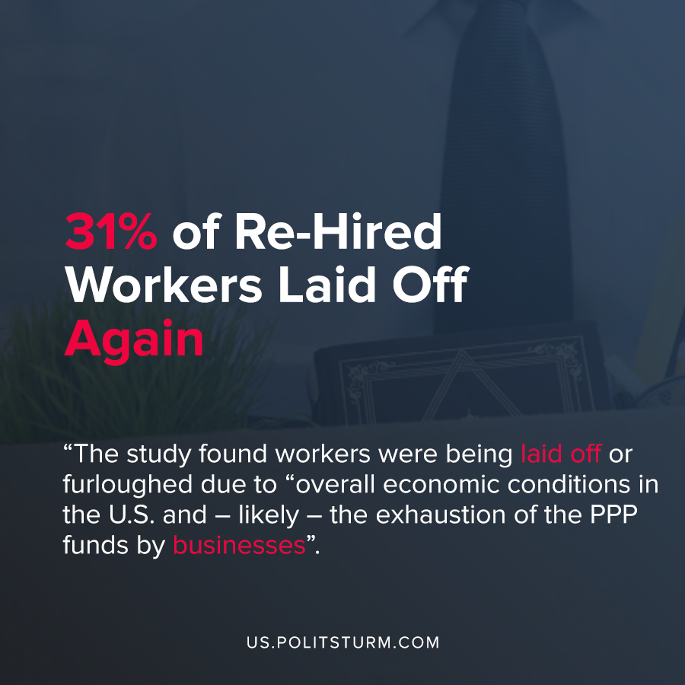

Original article
2020-08-07
1 min read

A recent survey was conducted of workers who were laid off or furloughed earlier in the year but were re-hired. Of the workers who were laid off or furloughed, 31% reported being laid off again and 26% report being told by their employer that they may be laid off again.
In response to the pandemic and the most recent capitalist crisis of overproduction, the U.S government passed the Coronavirus Aid, Relief, and Economic Security (CARES) Act. This act authorized the U.S. Treasury to issue $521 million in forgivable loans through the Paycheck Protection Program.
One of the conditions of the Paycheck Protection Program was that the employers needed to retain their workers. Employers were able to get loan forgiveness for the portion of the loan used towards “payroll costs and any payments of mortgage interest, rent, and utilities” in the eight weeks following the loan issuance.
The interpretation of the survey found workers were being laid off or furloughed due to “overall economic conditions in the U.S. and – likely – the exhaustion of the PPP funds by businesses that had used such loans to place their former employees back on payroll, whether or not they had work for them”.
The second round of layoffs and furloughs was actually higher in the states which at the current time are not experiencing COVID-19 surges. This led to the conclusion that the decision to layoff or furlough workers had a strong economic component.
Due to the private ownership of the means of production under capitalism, profit-maximizing capitalists have an instrumental role in the hiring of labor. Now that they have met the basic conditions of forgivable loans, capitalists will layoff or furlough the laborers leaving them in a desperate situation. Under a socialist economic arrangement, the decentralized capitalist system predicated on the exploitation of labor will be replaced by an economy run in the interests of the workers themselves, devoid of unemployment and crises.

Sources: 1 , 2 , 3

Original article

