3 in 5 Older Workers Could Retire in Poverty
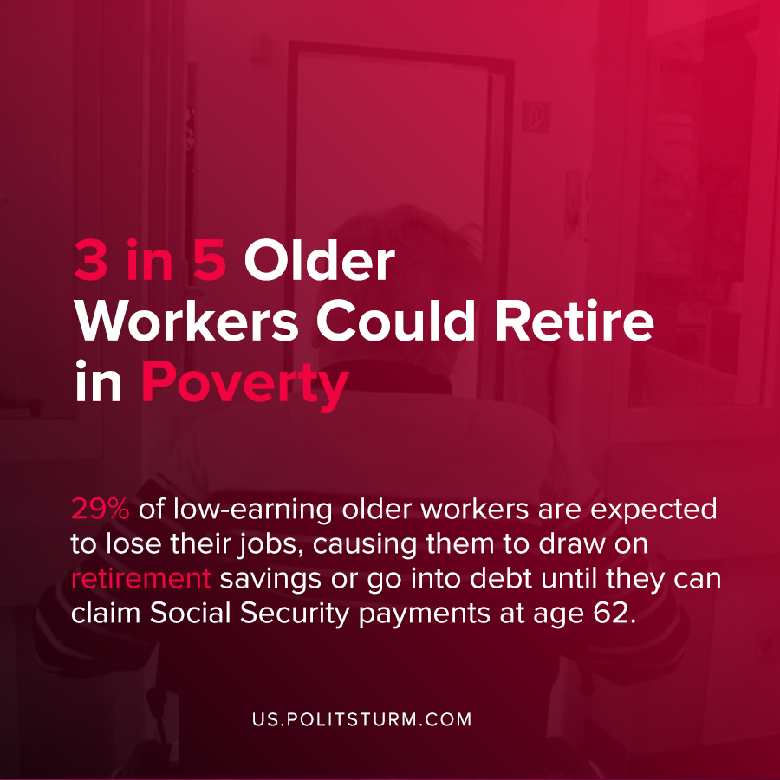

Original article
2020-10-10
1 min read

According to new research conducted by the Retirement Equity Lab at the New School, almost 3 in 5 older workers will retire in poverty due to the recession and coronavirus pandemic.
29% of low-earning older workers are expected to lose their jobs, causing them to draw on retirement savings or go into debt until they can claim Social Security payments at age 62.
While low-income older workers were already facing the prospects of poverty in retirement, approximately 1 million additional people in this group will be forced into poverty as a result of the recession.
The story is similar for middle-income workers, defined as those who earn between $48,000 and the Social Security earnings cap of $137,000 annually. 1.1 million older workers from this group will be forced into poverty as well.
Under the capitalist economic system, the retirement of older workers is precarious and subject to the repercussions of the recurrent crises of overproduction which condemns millions in the U.S to poverty. A socialist mode of production, by contrast, would not be subject to crises and would provide workers with stability in retirement.
Source: 1

Original article

