27% of U.S. Workers Fear Layoffs
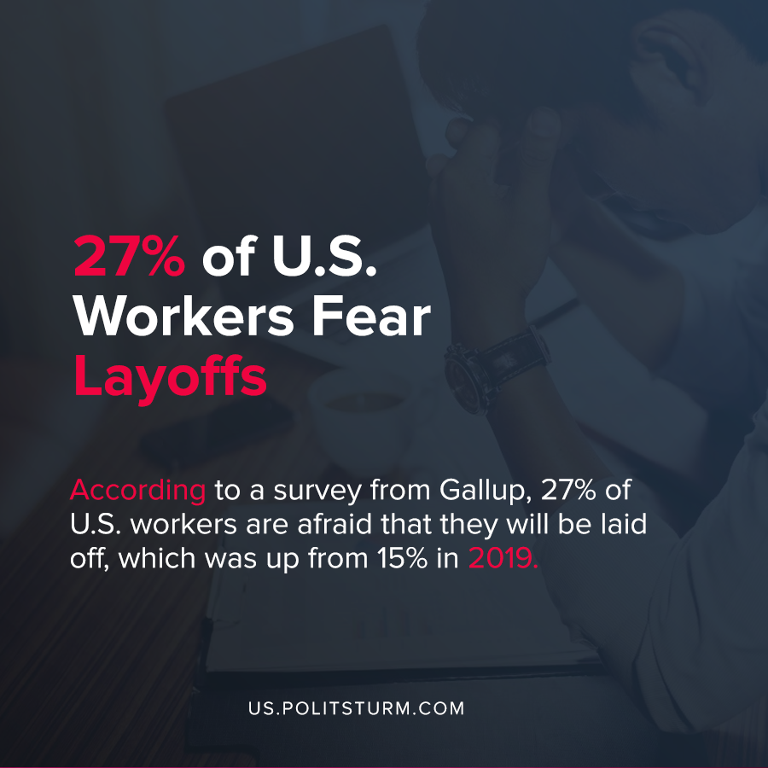

Original article
2020-09-10
1 min read

According to a survey from Gallup, 27% of U.S. workers are afraid that they will be laid off, which was up from 15% in 2019. There was a similar increase in the number of workers who feared that their hours would be reduced, which also spiked from 15% to 27% over the last year.
The survey also revealed that 46% of workers feared layoffs, work hour reductions, and wage or benefit cuts. The survey spiked to the highest levels since the last capitalist crisis which occurred after 2008.
Due to the material changes brought about by the latest capitalist crisis of overproduction and the coronavirus pandemic, workers’ sentiments about their employment have been adversely affected.
Under capitalism, employment is coordinated through the labor market which is subject to periodic upheavals. During a crisis, workers are thrown out of their jobs, effective demand plummets, and workers fear for their well being.
For as long as the capitalist economic system exists, workers will never be ensured employment and social guarantees that exist under a socialist economic arrangement. With every capitalist crisis of overproduction the insecurity and instability of the worker’s livelihood becomes readily apparent.

Source: 1

Original article

