24 Million Young Adults Live at Home
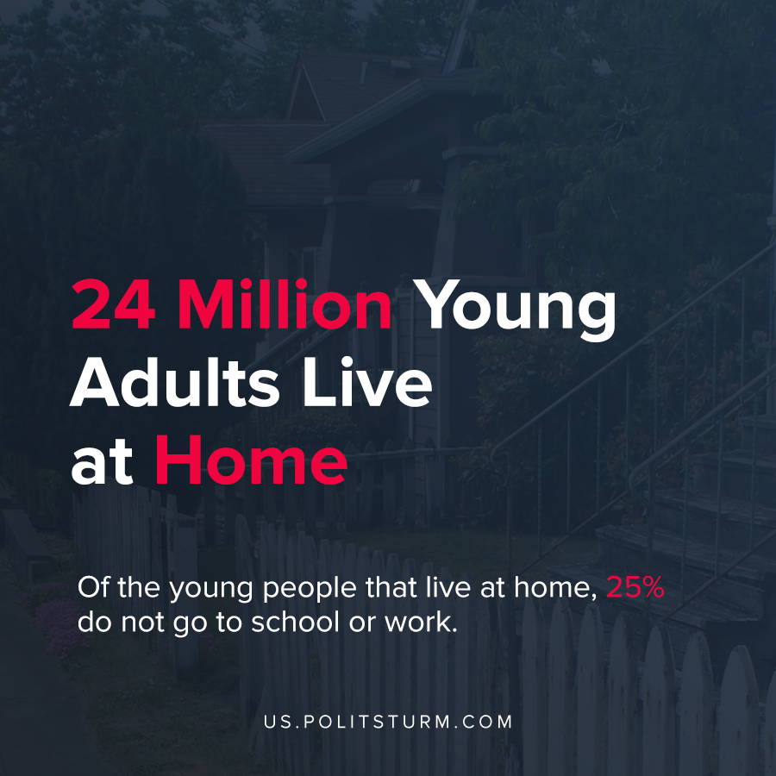

Original article
2021-04-21
1 min read

A recent publication by the U.S. Census entitled The Changing Economics and Demographics of Young Adulthood: 1975–2016 details demographic changes occurring in the U.S. over time. One of the insights of the research was that there are 24 million 18-34 year-olds that are still living at home.
The trends in data showed a move away from independent living and towards familial living arrangements over the time period investigated. At the same time, the percentage of young men living in poverty has increased.

“In 1975, only 25 percent of men, aged 25 to 34, had incomes of less than $30,000 per year. By 2016, that share rose to 41 percent of young men.” (Incomes for both years are in 2015 dollars.)
Of the young people that live at home, 25% do not go to school or work. The capitalist economic system does not guarantee the right to work and creates a massive reserve army of labor. The deindustrialization and financialization of the imperialist U.S. have changed the economic conditions. Young adults are less likely to be financially secure and thus are more likely to live at home. The capitalists who privately accumulate fortunes collectively push the negative repercussions of their actions onto the working class.

Source: 1

Original article

