23 Million Renters Across the U.S. Face Eviction
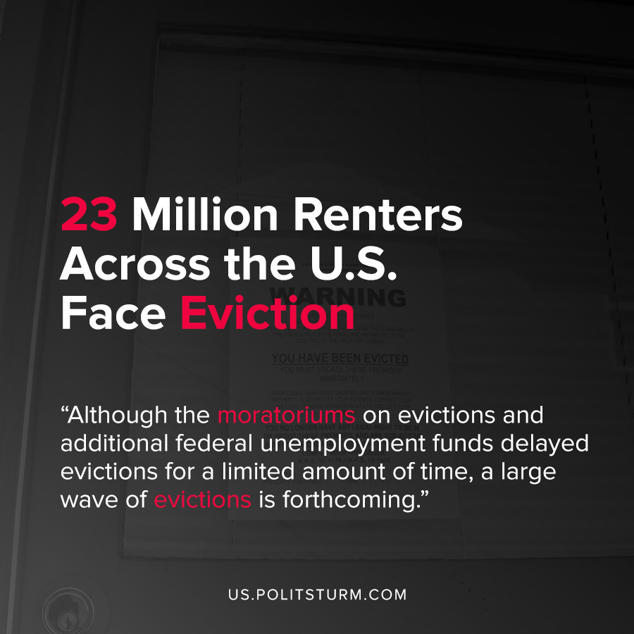

Original article
2020-08-05
1 min read

According to new research by the Aspen Institute, between 19 and 23 million renters in America are at risk of eviction. Enhanced unemployment benefits of $600 at the federal level expired at the end of July, and many of the 44 million Americans who have filed for unemployment will have difficulty paying for rent.
The study also details the lasting impact that evictions have on displaced families including the risk of homelessness, difficulty finding future housing, disruption of childhood education, among other negative repercussions.
Different states across America have different laws regarding whether tenants can be lawfully evicted during the pandemic. However, many of the moratoriums on eviction have expired leaving tenants vulnerable.
Landlords, through their private ownership of property, are able to obtain rents as unearned income in the same way that capitalists obtain profits as unearned income. In this way landlords are able to live off the labor of the working class and also exist as an exploiting class within society. The legal system which serves the interests of the dominant classes in society, the capitalists and landlords, will soon allow the enforcement of evictions across the United States.
Although the moratoriums on evictions and additional federal unemployment funds delayed evictions for a limited amount of time, a large wave of evictions is forthcoming. The capitalist system of housing in the United States is fundamentally based upon the private ownership of housing as a commodity, with a limited system of federally subsidized housing.
As such, housing is priced in such a way that it delivers unearned income to landlords and real estate speculators and investors, and when rents are not paid on the property the renters are thrown out. During the most recent crisis of overproduction and the concurrent coronavirus pandemic millions of workers lost their jobs which impacted their ability to pay rent. Socialism, as opposed to capitalism, is not subject to crises of overproduction and would not be predicated upon providing unearned income to the exploiting capitalists and landlords, but to providing housing to the working class.
Sources: 1 , 2 , 3 , 4

Original article

