23 Migrants Missing off the Coast of Italy
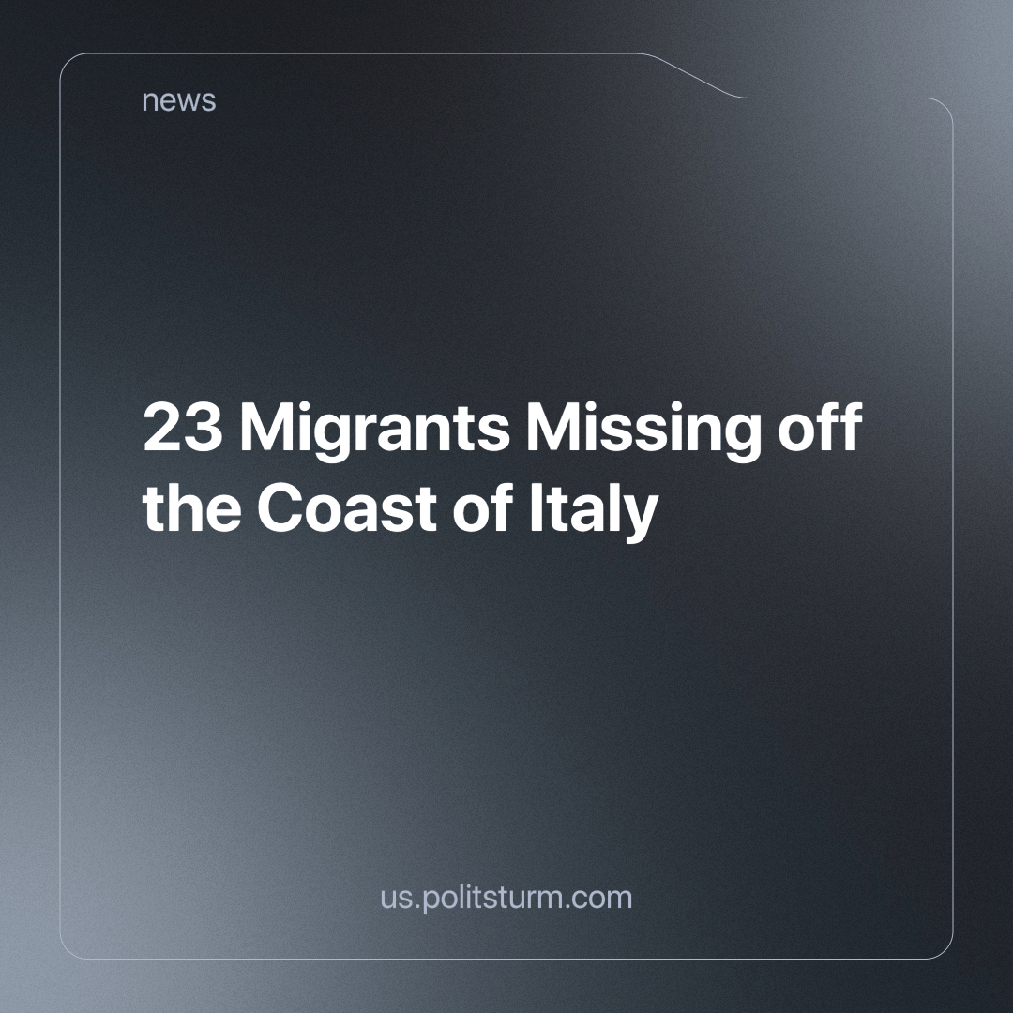

Original article
2024-06-02
3 min read

Recently, the Italian National Guard reported that about 23 migrants are missing after departing by boat from Tunisia to Italy. Tunisia is facing a migration crisis, replacing Libya as the main departure point for people fleeing poverty and conflict in Africa and the Middle East in hopes of a better life in Europe. The National Guard said it has deployed floating units and informed the navy to help in the search for missing persons [1][2].
Migration in Italy is a complex and multifactorial phenomenon, deeply rooted in the dynamics of global capitalism. The economic and political conditions that force millions of people to leave their home countries are often the direct result of the policies and practices of capitalist powers, which create and perpetuate inequality and instability. Capitalists, in their relentless pursuit of profit and resources, destabilize entire regions through aggressive resource extraction, economic exploitation and military conflicts, creating unbearable living conditions and forcing many people to migrate in search of a better life.
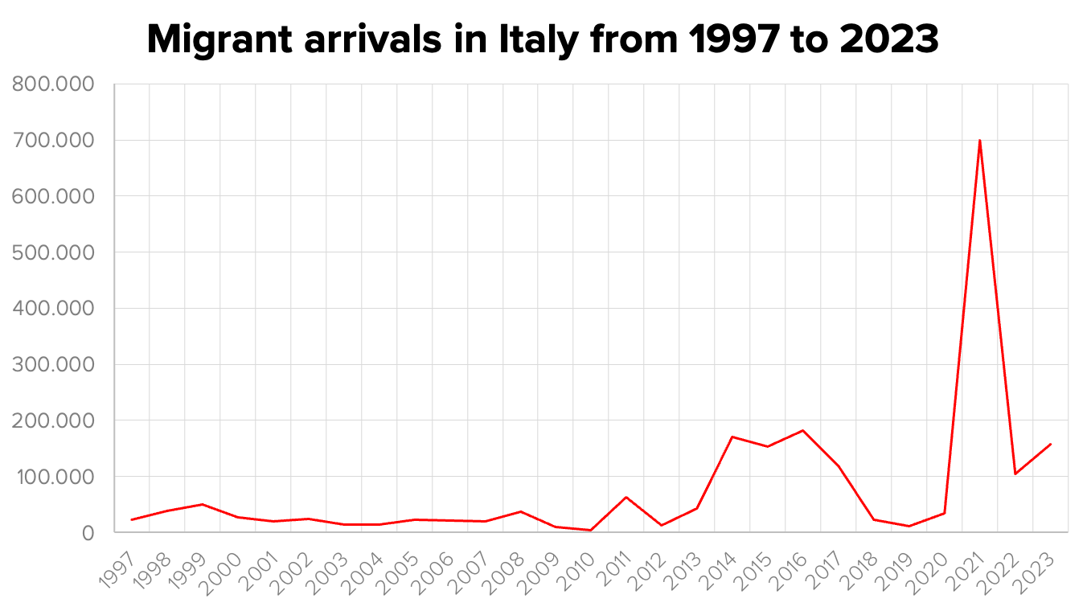
A prime example is Ukraine in 2021, where political instability and conflict caused a massive exodus, with the number of migrants to Italy reaching 700,000. This phenomenon is clearly visible in the Italian migration data (depicted above) and demonstrates how capitalist policies can create humanitarian crises[3][4][5].
Once migrants arrive in Italy, they join the ranks of some of the most exploited labor in the country, as they are desperate and often unfamiliar with the local language and culture. Although not their fault for seeking a better life, their presence affects the Italian labor market and decreases the average wages of Italian nationals and residents. Capitalist elites exploit this situation by using nationalism, racism and chauvinism to fragment the working class, reducing class solidarity and lowering wages even further for all, regardless of their nationality by creating these obstacles to collective bargaining for the workers. Migrants thus become scapegoats, while the real perpetrators of economic hardship are the policies and practices of capitalists.
Migrants represent a cheap labor force that capitalist firms take advantage of, often employing them in extreme working conditions for derisory wages. This exploitation not only keeps labor costs low but also perpetuates a cycle of exploitation that benefits corporations and capital. Migrants, driven by the need to survive, accept these working conditions that would otherwise be unacceptable to local workers.
Thus, migration in Italy, but also in other European countries, is the result of the economic and political structures of global capitalism. Capitalists not only create the conditions that force people to migrate and leave their homes and hearth but also use the presence of migrants to fragment the working class, lower wages and increase competition for jobs. Therefore, the real “cookie stealers” are not the migrants, but the corporations and elites who exploit and divide the working class for their own gain. The solution to this problem cannot be found in the repression of migrants, as the Meloni government is trying to do, but in a radical change of the global economic system toward a system of common ownership of the means of production - socialism - that eliminates class distinctions and allows all working people to live with dignity.
The “cause” of this discrimination at work and in daily life is neither education nor geographical location. Rather, the capitalist economic system allows the bourgeois class to discriminate on the basis of race. It would be a grave mistake for the working class in its class struggle not to recognize how the capitalists sow division amongst them on the basis of race, nationality or religion to distract workers from united against their systematic oppression under the capitalist system.
Source:
[1] tgcom24.com - “Migranti, naufragio in Tunisia: le autorità cercano 23 dispersi” dated May 19, 2024;
[2] sabcnews.com - “Tunisia says 23 migrants missing after setting off in boat to Italy” dated May 18, 2024;
[3] openpolis.it - “Gli arrivi di migranti in Italia dal 1997 al 2020” dated April 27, 2023;
[4] unicef.it - “Rifugiati e Migranti in Europa” dated April 29, 2024;
[5] integrazionemigranti.gov.it - “Nel 2023 sbarcati in Italia 158 mila migranti, +50%” dated January 8, 2024.

Original article

