2024 Russian Presidential Election: The Tactics of The Left and The Tasks of The Communists
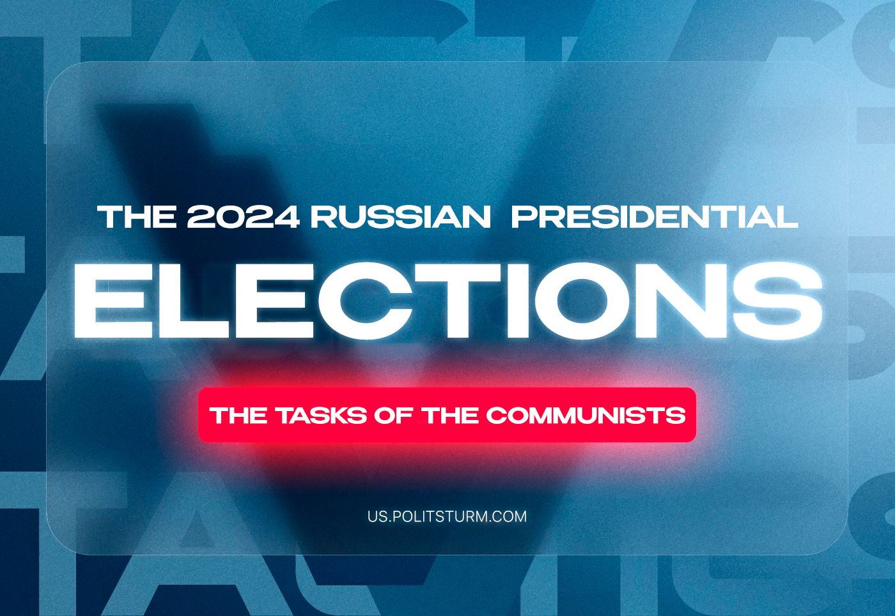

Original article
2024-03-15
20 min read

The 2024 Russian presidential elections started today and will take place over this weekend. The Russian branch of Politsturm has prepared an article explaining everything that foreign communists need to know about these elections.
I. The elections are taking place in the context of a “special military operation” by Russia in Ukraine that has been going on for two years now combined with a total cleansing of the political space from both the right and left opposition. Over the past year, the government has arrested or prosecuted all potential opponents. Only forces loyal to the government remain in the political sphere. In the conditions of the ‘Special Military Operation’, the Russian government introduced numerous laws that constitute military censorship. Thus, it is prohibited to call the current events in Ukraine a war, critical statements about soldiers and officers of the active army are prohibited, and the disclosure of any information related to the military industry is prohibited too.
II. Candidates from the formal opposition do not pose a threat to the government. If previous presidential and parliamentary elections allowed for the presence of candidates who disagreed with the government’s course, this is not the case in the 2024 elections. The ballot includes Putin and candidates from “system-compliant” parties, who are as gray and inconspicuous as possible. From the “Communist Party of the Russian Federation,” which fully supports Putin, Nikolai Kharitonov, one of the members of the Central Committee of this false “Communist Party,” was nominated instead of the long-standing candidacy of the party leader, the social-chauvinist and opportunist Gennady Zyuganov. The “Liberal Democratic Party of Russia” replaced the populist and nationalist Vladimir Zhirinovsky, who died in 2022, with Leonid Slootsky, around whom a scandal related to sexual harassment unfolded several years ago.
The government-controlled “New People” party was created in 2021, with the goal of appealing to liberals, and nominated the previously unknown Vladislav Davankov. The hopes of the liberal opposition, however, were tied to Boris Nadezhdin, who is not formally allowed to participate in the elections due to “an excessive percentage of false signatures in support of the candidate”.
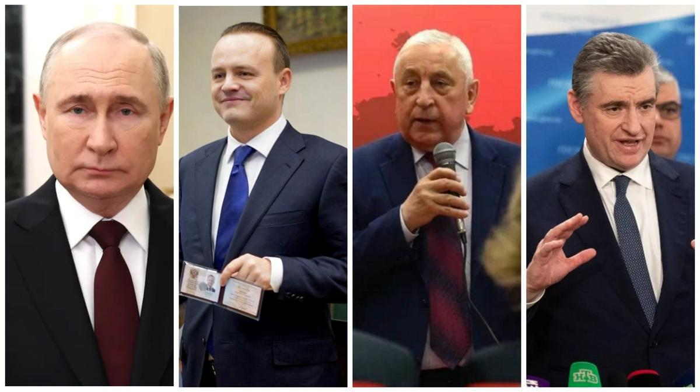
Candidates: Putin, Davankov, Kharitonov and Slootsky
The government deliberately contrasted the current president with the most dull and unattractive candidates possible. Not only do they not represent any opposition to the president and his course, but they also serve as an additional incentive to vote for Putin. Disappointed voters among ordinary citizens will be ready to vote for Putin just because they know him. “Who are all these people on the ballot? I only know the current president, Putin and he may not be the best, but he is proven. It’s better the devil you know than the devil you don’t.” – this is often the logic of the average Russian.
It is significant that during the election campaign, all candidates tried to avoid answering the question “Are you ready to win the elections?”, trying to conceal even a hint of any real opposition to Putin.
Formally, there are several candidates on the ballot. In reality, the issue is not whether Putin will be elected or not, but how many people will turn out to vote; regardless of who they vote for, the current president will be re-elected.
III. The goal of the elections is the re-election of Putin with maximum turnout. On the one hand, the elites know that Putin will be elected. On the other hand, the Russian population also has no illusions about the fake ‘opposition’ candidates and knows that these elections, which are a sham even in comparison with “traditional” Russian elections, serve only the purpose of re-electing Putin. As a result, turnout inevitably falls.
The main task of the ruling class in these elections is to ensure a maximum turnout. A high turnout will give a stable image of the legitimacy of the electoral process, in which the expected re-election of the "main candidate" to be the president is supported wholeheartedly by the people. The legitimacy of the elections means the legitimacy not only of the entire existing socio-political system but also of the ideological course and policies of the ruling class.
The image of the people's active participation in the presidential elections, processed by the propaganda machine, strengthens the image of popular support, influences the hesitant and doubtful sections of the population and strengthens the authority of the government.
This is very important for the ruling class in Russia. Otherwise, we would not see the traditional mobilization of administrative resources to encourage people to go to the polls. We would not see the coercion of employees of budgetary organizations to install a special application to verify a person's presence at the polling station. We would not have seen the active introduction and use of remote e-voting, which, in addition to further controlling the voting process, increases the turnout of those who cannot or do not want to go to the polling stations in person.
IV. The broad left is trying to win over the liberal audience to their side and is busy sorting out relations amongst themselves instead of doing serious organizational work.
At the end of February, several “left” bloggers, politicians and media announced the creation of the “Spravedliviy Mir” (a play on words that can be translated as “Fair World”, but also as “Fair Peace”) initiative. This broad left coalition proposed its own tactics for the upcoming Russian presidential elections.
The composition of the "initiative" is patchy but symptomatic: broad left blogger Andrey Rudoy* (supported by France’s Melanchon), Moscow City Duma deputy Evgeny Stupin*, Moscow student activist Mikhail Lobanov*, former liberal “Yabloko” (Apple) party member V. Bovar and a number of other individuals, as well as the YouTube channel and media resource "Vestnik Buri", social-democratic "Russian Socialist Movement" and some minor Telegram channels.
The participants of this ‘initiative’ are urging people to visit the polling stations on 17 March and spoil the ballot paper, which, in their opinion, should become a kind of alternative to the "against all" column.
This tactic is justified by them on the grounds that elections are a way of "letting the authorities know that we will not play on their rules", that it is necessary to use elections to "mobilize protests and promote our ideas", to "remind the authorities that we are there and that we do not support them". It is also claimed that spoiled ballots will be included in the total number of votes, thus reducing the percentages of the "main candidate" and other candidates.
At the same time, the "initiative" is backed by some kind of "minimum program" that "could unite tens of millions of people who currently have no voice".
Does this action have a real, practical meaning? In response to the question of why the "spoiled ballot" tactic is necessary, the authors of the "initiative" say nothing about what it should lead to. There is no second step in the logic of their spoilt ballot tactics (as there is, for example, in voting for an "alternative” candidate). All that is suggested is for people to come and spoil the ballot paper and, if possible, take a photo and send it to the initiative's email address.
The whole logic of the operation falls apart when we ask a few simple questions:
Will it affect the falsification of the results? No, because the state has complete control over the entire electoral system. So there would be no effect on the elections (if the communists had wanted to affect them).
Will it stop the intensification of repression and reaction? No, because the action is in no way capable of disarming or weakening the repressive apparatus of the Russian state.
Will it lead to the "politicization" and unification of all those who sympathize with communism? No, because it is a one-off action that does not imply or call for the building of an organizational structure and a broad agitation campaign. The format of the action itself does not imply the creation of links between its participants. Moreover, it is carried out by openly opportunist and even far-from-communist “left” elements.
The video on the "initiative" argues that voter turnout has long been a low priority for the authorities and does not affect the legitimacy of elections. As an example, it cites the data on voter turnout in the 2016 State Duma elections, which was 47.9% and had no significant impact on the perception of the "legitimacy" of the system.
Firstly, they overlooked that the next parliamentary elections in 2021 were, for the first time, held with a three-day voting format, which was introduced partly to involve more people in the electoral process by extending the voting period.
Secondly, the Presidential Office in Russia has far more real influence than the parliament. Consequently, the procedure of the election itself is more important for the ruling class. In the case of parliament, which plays the role of a legislative servant of the political system, the turnout for its election is not so important because the legitimacy of the parliament is indirectly supported by the legitimacy of the President’s power. The President approves the decisions of parliament, not the other way around.
Thirdly, the situation in 2016 (as well as in 2021) is not the same as the current situation in 2024. We are already in the third year of the Ukrainian crisis, and the level of material well-being of the population has significantly decreased. Also, in 2023, there was a rebellion of the PMC Wagner, which exposed the instability of the power structure that rules Russia and the lack of unity among the ruling group of capitalists, as well as casting a shadow on the reputation of the "main candidate". Both the contradictions between labor and capital and the contradictions within the ruling class are growing. In this situation, the need for a demonstration of legitimacy is an urgent necessity for the whole political system.
Although the size of the audience of the authors of the "initiative" and the scale of the potential participants of their action should not be exaggerated, their calls to participate in these elections play in one way or another into the hands of the bourgeois power, disorientate the workers and shift the emphasis away from the class confrontation.
At the same time, the actual vote of the voter does not matter to the ruling group of capitalists: whether he or she votes for an alternative candidate or spoils his or her ballot paper, the main thing is that he or she comes to the elections and increases the actual turnout. This is exactly what the ruling class wants from these elections.
In the 2012 presidential elections, about 800,000 ballots had already been spoiled. Considering this, a few hundred or even a few thousand ballots spoiled by these "leftists" will be a drop in the ocean when compared to the general mass. Especially so against the background of the tens of millions of ballot papers "correctly counted" according to special "correct" algorithms of the All-Russian Central Election Commission.
As a result, from the point of view of the struggle of the communists and the working class, the action has no practical meaning. It is a stunt, favorable only to grow the follower counts of those who try to advertise themselves in this way and "flirt" with the liberal opposition.
The "minimum programme" presented by the authors of the initiative consists of different points that have no common connection or logic. In addition to the demand for the people mobilized and sent to the frontlines to be returned and the end of the Ukrainian crisis, the left demands:
- Free day nurseries, kindergartens and schools;
- Increased maternity capital (state payment to mothers when they give birth), affordable housing for young parents;
- Indexation of pensions;
- Increasing the minimum wage and public sector salaries;
- Creation of new jobs;
- Cancellation of the pension reform;
- The "full right" to strike;
- Repeal of repressive articles of the Penal Code and release of those convicted under them;
- Credit amnesty;
- Increased federalisation, introduction of "real self-government", equal distribution of taxes between local and federal budgets;
- Lifting of restrictions on opposition candidates, etc.
They also present an eco-advocacy programme.
As a result, neither the programme's message nor its aims and objectives are entirely clear. Presented as a list of class-neutral ‘good wishes’, the "program" plays the role of an ideological-populist platform aimed largely at a liberal audience, the petty bourgeoisie and the labor aristocracy.
Apart from the question of the strike, the "minimum programme" does not really address any of the class tasks of the proletariat. Most of the points are of a blatantly liberal character: defending the rights of the liberal opposition, local regionalist groups opposing Moscow power, demanding "guarantees" of security for the countries neighboring Russia, etc.
For each of the participants in the coalition, the "programme" is a further confirmation of their ideological departure from the class positions of the proletariat.
The use of bourgeois and petty-bourgeois rhetoric of "protest demonstrations" by the participants of the "Initiative", the emphasis on actionism with a class-neutral agenda, and the appeal towards a liberal audience is an open manifestation of the line of tailism in the communist movement and aids the subordination of the working class to the ideological and practical line of the bourgeoisie.
To follow the liberals is to lose one's communist position, to move away from the class interests of the workers, and to take the side of one of the groups of capitalists fighting each other and their political agents.
The individuals, media and organizations that were part of the "initiative" are not surprising as they previously acted as agents of tailism in the Russian left movement. None of the participants have ever been characterized by a consistent Marxist position and has always tended towards reformism and near-liberal rhetoric. Their rapprochement with the liberals is a natural result of their initial non-Marxist position, opportunism and years of ideological degradation.
It is also worth looking at the story around the “Russian Labor Front” (RTF). We would not ordinarily single out this organization. However, the head of the RTF, Alexander Batov, and the leadership of the “Revolutionary Communist Youth League (Bolsheviks)”, which is also part of the RTF, portray their organization as “real communists” to the Solidnet parties and, above all, to the leadership of the KKE. He has managed to do this using personal connections established during numerous trips to international conferences, congresses and Solidnet “Meetings” through the RCWP.
The RTF was created under the name "ROT-Front" in 2012 as a broad left-wing coalition to participate in elections under the leadership of the "Russian Communist Workers' Party", which had been deprived of its registration as an official political party.
Having supported almost all the initiatives of the social-chauvinist RCWP for 10 years and their position on the ‘people’s republics’ in Donbass, ROT-Front gradually separated from this party. At the beginning of the ‘Special Military Operation’, the RCWP expressed its position on the conflict, which was in support of the Russian Federation as a “progressive state”. This served as a reason for the split of part of the leadership of this party, their youth organization and their frontal organization.
The RTF takes an opportunist view of communist tactics and strategy and promotes the theory of "stages": the need for the labor movement to initially develop on a platform of economic demands, after which the workers must somehow move on to political ones. This theory of economism was crushed by Lenin and the Bolsheviks at the turn of the 19th-20th centuries. Representatives of this organization, such as Oleg Komolov and his Russian-language YouTube channel “Prime Numbers,” openly promote the need to revise Marxism-Leninism and combine it with Wallerstein’s “world-system theory”.
The reasons for such views lie in the structure of the RTF: it includes trotskyists, social democrats, anarchists and self-described communists from among the former members of the RCWP.
On March 10, RTF published its official position on its Telegram channel, calling for a boycott of the elections. On the same day, Komolov’s channel made a post, stating that there is no clear position among the members and calling for the audience to ‘judge the arguments’ in the comments. It’s worth mentioning that Komolov supported the “Fair World” initiative by publishing a video of Rudoy* on this topic without any negative comments on his Telegram channel.
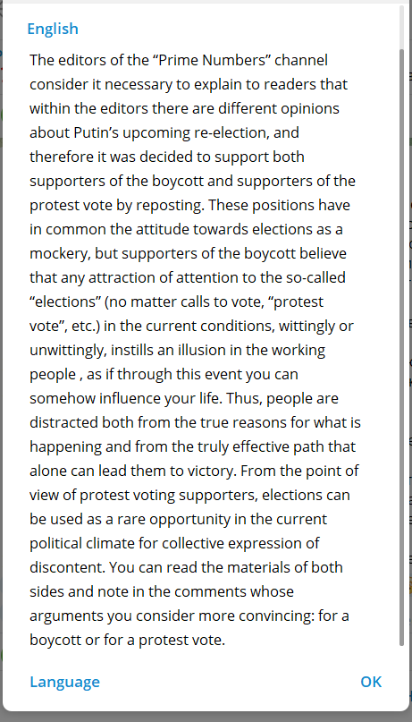
The lack of a unified position on fundamental issues, and the desire to gloss over the problem, to present a solution that satisfies both sides is a traditional component of opportunistic elements, and RTF is no exception.
It is also indicative that in the previous presidential elections of 2018, the RTF did not have a clear position as well. Then “ROT-Front”, as it was called back then, carried out a campaign to nominate a little-known crane operator for president with similar slogans about the need to “do at least something” and claiming that “it’s better than nothing.” Having wasted a lot of money and time, their candidate was rejected.

Communist position
Every election raises the question of what position the Communists should take. And every time opportunist organizations and figures put forward tailist and actionist tactics which are not in line with the real tasks of the communists.
Although these elections are taking place under special conditions – the still extremely weak workers' and communist movement, the sharp aggravation of inter-imperialist contradictions in the world, the hardening of reaction and the deepening of the crisis in Russia - the current tasks of the communists remain the same.

1. Exposing the politics of the capitalist class
Communists must consistently explain to the workers the nature and meaning of bourgeois democracy - be it presidential, parliamentary and other elections under capitalism: they exist to create an image of the legitimacy of the existing system of exploitation of labour and to keep millions of workers subservient to the capitalists.

2. Propaganda of Marxism-Leninism
As long as the working class does not realize its class unity and its interests, as long as the workers remain in class hibernation and as long as the faith in bourgeois politicians remains among them, the task of comprehensively exposing the capitalist system and educating the population remains.
The explanation of the contradiction between labor and capital, the causes of the workers' poverty and misery, the deception and hypocrisy needed to maintain capitalist power, the foundations of capitalism and the fundamental class interests of the workers are the main lines of communist agitation.

3. Establishment of the Communist Party and organization of workers
An organized force can only be opposed by an equally organized force. The proletariat cannot achieve its class objectives without its own organization. Such an organization is the Communist Party. As long as there is no party – a real party linked to the broad strata of the working class, based on communist positions and advanced theory – no action and no activity can achieve anything for the cause of the working class.
Since this is the task of the proletariat and not of the petty-bourgeois masses and the opposition groups of the capitalists, the main and urgent task of the communists and all conscious representatives of the workers is to build a Communist Party. A trained cadre and a developed organisational structure are the most important tasks of the communists of Russia.
Education, agitation, and the economic struggle of the workers, let alone political action, cannot be fully effective if there is no organizational structure which can gather and organize under its command all the advanced strata of the proletariat. Without a united organization, leadership and direction of the working class, its struggle is doomed to failure and it cannot achieve its primary tasks, such as establishing its own power.

Conclusion
The false conclusion is drawn from the present situation that the communists need "at least some action". Any attempt to draw attention to the real tasks of the communists is met by a barrage of primitive accusations and demagogy from the broad left-wing opportunists in the spirit of "you are calling for nothing to be done".
With their logic, the required day-to-day consistent work of building the party structure – the most important task of the communists at this stage – is replaced by liberal actionism, which is useless for the class struggle.
Russian communists stand against the endless squabbling of various broad left-wing bloggers who have turned the crisis of the Russian communist movement into their own business. They are parasites feeding on the difficult situation in the country, doing nothing to really help unite workers and communists in a single organization.
Only petty-bourgeois elements, who rush to take part in every adventure under the current conditions of aggravated reaction and inter-imperialist contradictions, can argue that the communists need "at least some action". Impulsive reactions to political events and actionism are characteristic of petty-bourgeois politicians, not of communists who are guided in their work by Marxist-Leninist tactics and strategies of struggle.
Whatever the situation, as long as the task of building the party remains, the activities of the communists must be carried out in this direction. This means strengthening the communist organization, training and replenishing its ranks, maintaining its personnel and systematically interacting with the workers' collectives.
We in Politsturm are doing this work and we urge you to join us.
*Recognised as foreign agents in the Russian Federation

Original article

