20 Years of Putin's Economy
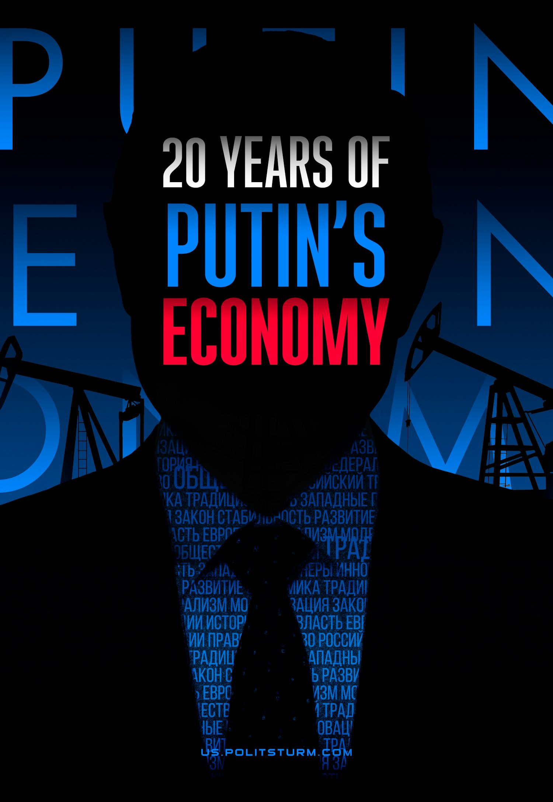

Original article
2023-01-27
27 min read

For more than twenty years, Vladimir Putin has been the key power figure in the Russian Federation. For 17 years, he has been in the presidency, and for 4 years, he has served as prime minister. So 21 years in power in total. Russian bourgeois propagandists call the period of his leadership the "rise of Russia from its knees". In their opinion, during this time, the country has overcome the collapse and devastation of the 1990s and took the path of "sustainable development".
Official Russian propaganda keeps talking about the recovery and development; promises of a strong emerging economy, innovations and modernization have resounded since the beginning of Putin's rule. The same routine promises about improving the population's well-being have been promoted for decades.
And now, at a new stage in the aggravation of the international situation, accompanied by serious sanctions pressure, government officials and the official media assure people that "Russia was preparing for sanctions", "Russia will cope", and "sanctions will only push country's development", repeating slogans, which became mundane after 2014.
But the merciless reality has again shown the Russian Federation's extreme dependence on the supply of foreign goods and technologies, underdeveloped high-tech production and reliance on the export of the resource-extracting sector of the economy, and a low standard of living.
Let's see what has been promised to Russians and how the bourgeois state developed the economy during these 20 years.
I. Policy promises of the authorities and real results
Analysis of Vladimir Putin's promises meets a fundamental difficulty since it is hard to find more broad and vague assurances of success and development than those of the Russian President. Further in the article, we will analyse the fulfilment of the most concrete of those promises and check their implementations in practice. If the exact target indicators have not been put forward, we will compare them with the world average.
One of the rare indicators on which the President made specific promises is GDP - gross domestic product. The GDP indicator reflects the market value of all final goods and services produced per year in all sectors of the economy on the territory of a particular state for consumption, export and accumulation, regardless of the nationality of the factors of production used.
Even in the article "Russia at the Turn of the Millennium", published in Nezavisimaya Gazeta (Independent Magazine) on December 30, 1999, Vladimir Putin, a day before he became acting President for the first time, paid particular attention to GDP:
"I want to quote the calculations made by experts. It will take us approximately fifteen years and an annual growth of our Gross Domestic Product by 8 per cent a year to reach the per capita GDP level of present-day Portugal or Spain, which are not among the world's industrialised leaders. If during the same fifteen years we manage to ensure the annual growth of our GDP by 10 per cent, we will then catch up with Britain or France."
Already in 2003, in a message to the Federal Assembly of the Russian Federation, a promise was made to double GDP by 2010:
"Among our most important tasks ... I consider the following: doubling the gross domestic product ... in the period until 2010."
The promise of doubling GDP was fulfilled, unfortunately, not due to the leader's talent, but to recovery growth from a low start, after the hopeless decline of the 90s under favourable conditions for foreign trade. Even Vladimir Putin himself admitted it:
"We must also admit that the economic growth in Russia is primarily due to the favourable state of the world situation in recent years. Through an unprecedented improvement in terms of trade for our economy, Russia has received significant economic benefits and large additional revenues."
The main factor defining the favourable market situation was the price rise for hydrocarbons, Russia's main export commodity. For example, Brent oil from $10 per barrel in early 1999 gradually rose in price to $90 by early 2008.
By 2009, the potential for recovery growth was exhausted, favourable external conditions ended. So for more than ten years, Russia has had GDP growth slightly higher than the world average in quite years, and in times of crisis, the recession significantly exceeding the global one.
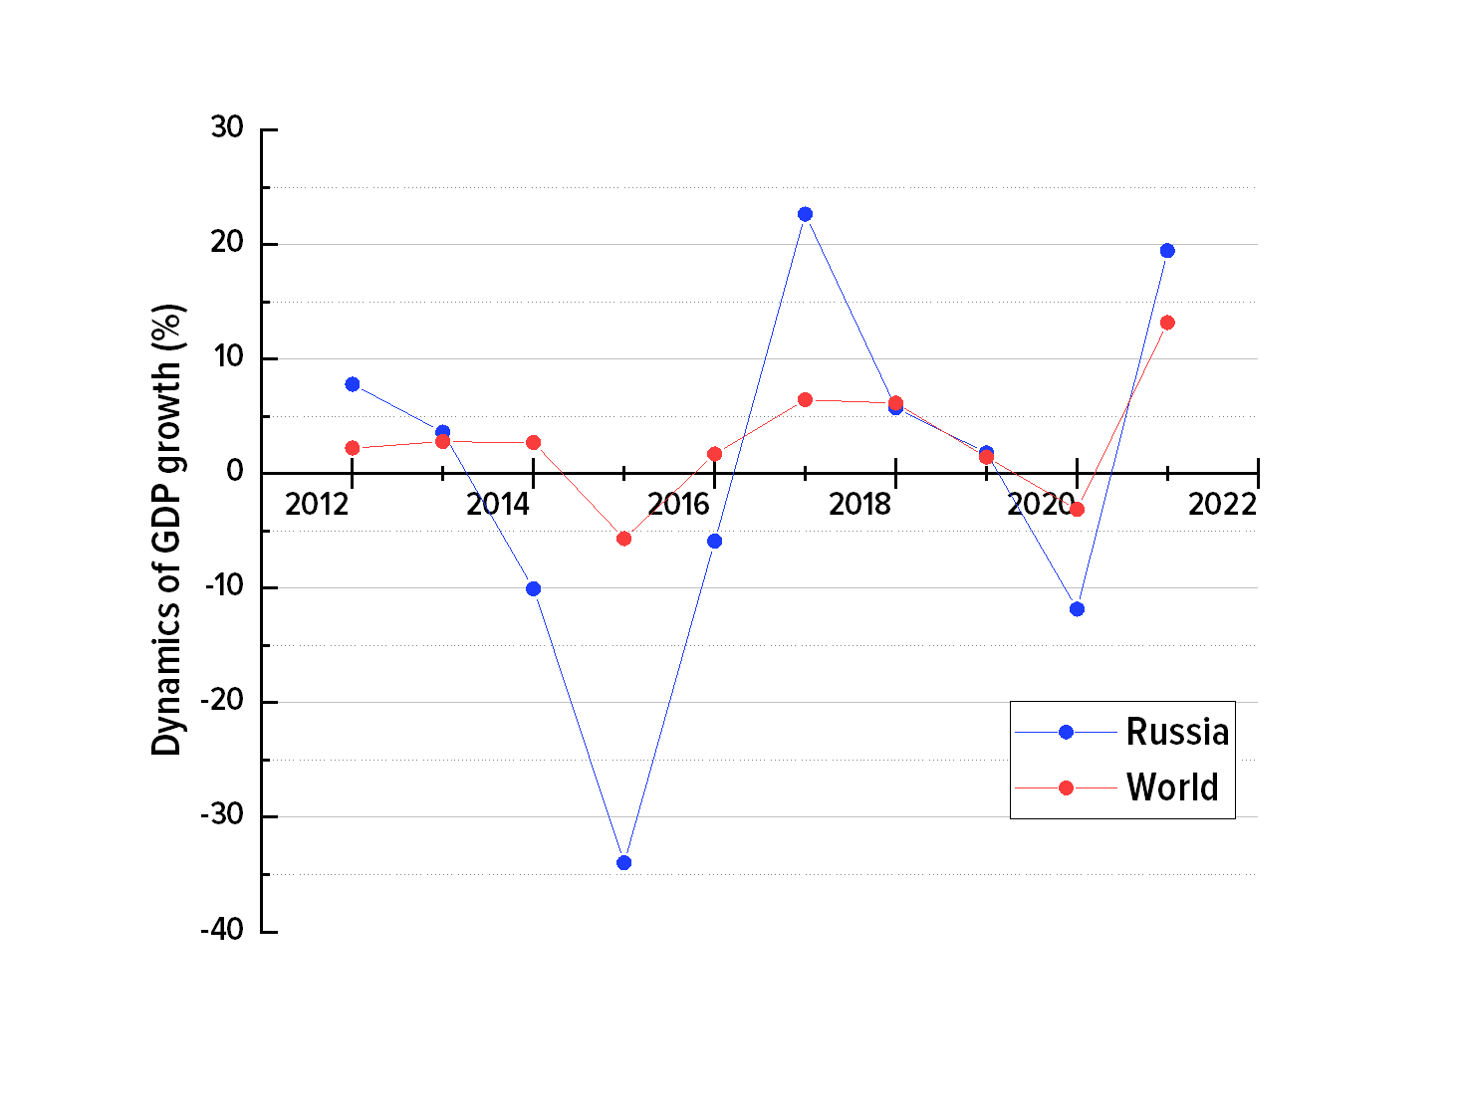
Graph 1. Dynamics of growth and decline of Russia's GDP and the total world GDP over 2011-2021 period, %
As a result, from 2011 to 2021, Russia's GDP fell by 15% (from $2.05 to $1.78 t), while the global GDP grew by 23% (from $73.85 to $96.1 t). Such a huge difference practically nullified attempts to catch up with the most economically developed countries.
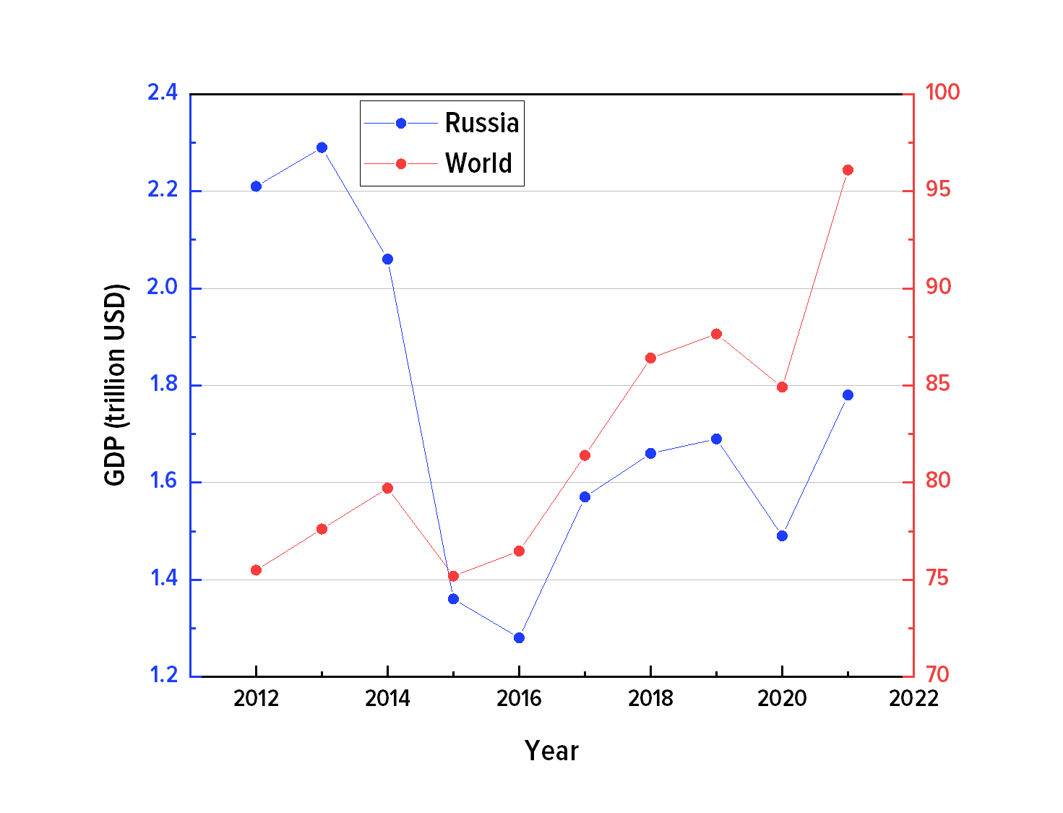
Graph 2. GDP of Russia and global over 2011-2021 period, trln. $
In absolute terms, GDP managed to draw up with Spain but not France and Great Britain. According to a more valuable relative indicator - GDP per capita - Russia lags behind even Portugal and Spain.
Another important topic for Vladimir Putin, which is raised in almost all programs and promises, is the well-being of the population and the fight against poverty.
In 1999: "The government is developing a new income policy that aims to ensure sustainable growth in the welfare of the population based on an increase in real disposable incomes of citizens."
In 2003: "Among our most important tasks ... I consider the following: overcoming poverty ... in the period up to 2010."
The most accessible indicator in this topic is the average salary, and, at first glance, there is a huge increase in it from 2,223 rubles (roughly 79$ with the corresponding exchange rate) in 2000 to 57,244 (777 $) in 2021, i.e. growth by as much as 2575% in ruble equivalent!
But if one subtracts the inflation,only 336% will remain, i.e. with inflation assumed to be zero, the average salary in 2021 would be 7,488 rubles (265$ with ER of 2000), which is not so impressive anymore.
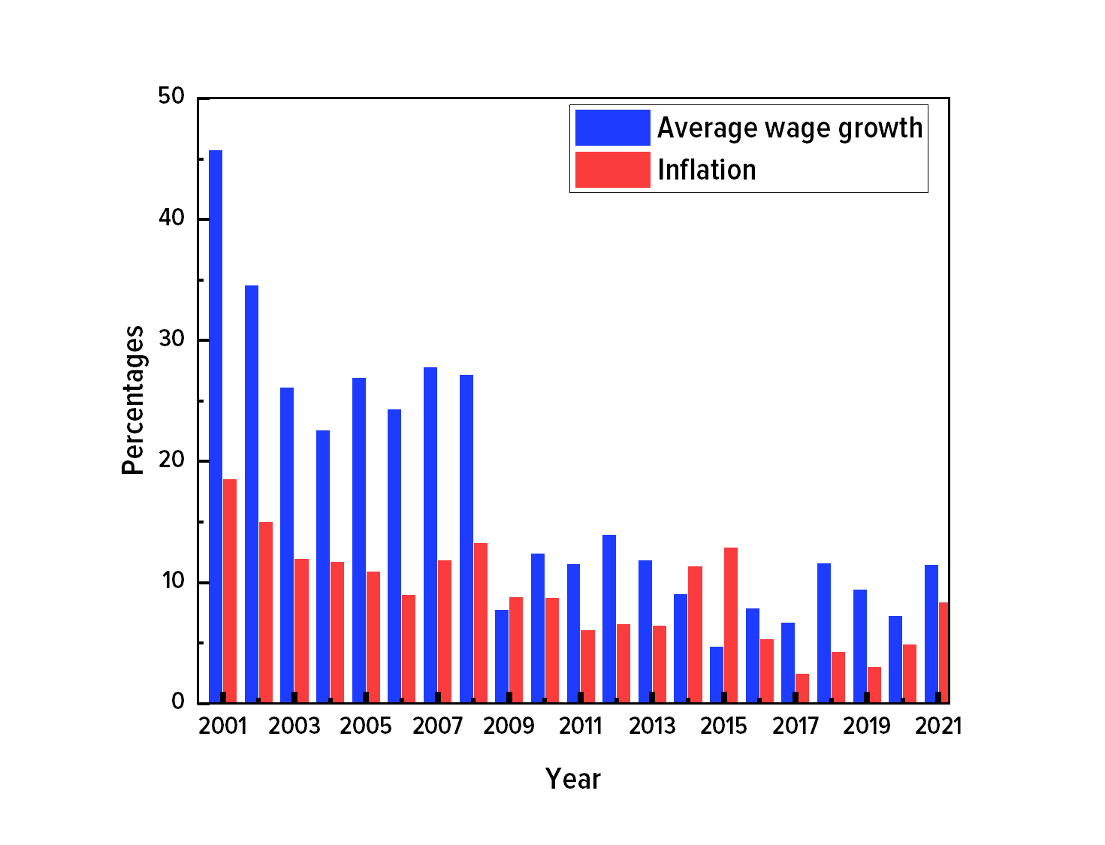
Graph 3.Average wage growth and inflation rate over 2001-2021 period, %

The graph shows that the most significant growth also occurs in the years of recovery and favorable foreign trade conditions, and since 2009 growth has slightly outpaced inflation; in the years of crisis yields to it.
Let's admit it: 336% growth in average wages is not such a huge number compared to 2575%, but still impressive.
However, it is worth remembering that the average wage is not the most objective indicator of the well-being of the population, since it does not take into account the uneven distribution of income. A more objective marker is the median wage - a value that divides the entire number of jobs into two equal parts: 50% are paid below this value and 50% - above.
Data on median wages would help paint a clearer picture of what is happening. However, the Russian Buro of Statistics (Rosstat) does not regularly calculate this indicator and does not publish enough data to make independent calculations.
Although the median salary in 2019 is known - 30,458 rubles (470$), and in 2020 - 32,422 rubles (449$), which is 36% and 37% less than the average salary for these years (47,867 rubles and 51,344 rubles). The such difference shows the uneven distribution of wages and the presence of ultra-high incomes among a small part of citizens, which creates a higher average wage on paper.
The situation is similar in the case of the struggle against poverty. Until 2007, there was an sharp decline in the number of citizens with incomes below the subsistence level. Then this value stabilized around 13%, which seems not much in terms of percentage, but in fact, it is more than 19 million people.
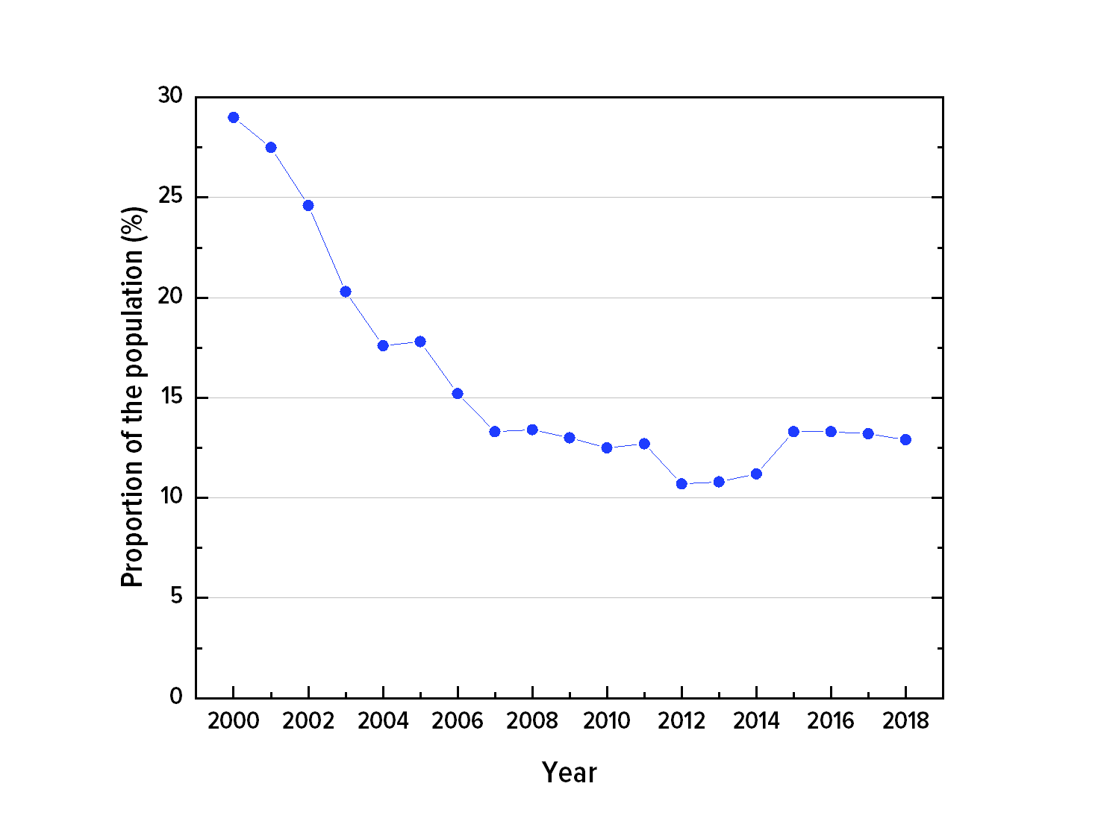
Graph 4. Population with incomes below the subsistence level over 2000-2018 period, %

It is worth to dwell in more detail how the cost of living is defined. The government of the Russian Federation (before it was a task of the Ministry of Labor) determined its value until 2021 based on the so-called consumer and food basket - a set of necessary products and goods necessary to support a person's natural life. For instance, in the first quarter of 2020, the living wage for the able-bodied population amounted to 11,731 rubles (162$). It is assumed that the spent for housing and communal services is 9.5% of the total expenses included to the subsistence minimum wage,, i.e. 1,115 rubles (15.4$). In reality the average spending of Russians on utility bills in 2019 amounted to 3,826 rubles (53$).
Thus, it's obvious that receiving a living wage it is impossible to pay for utilities, not even acquire an accommodation. The situation is no better for other categories of expenses. For example, the food basket doesn’t comply with World Healthcare Organisation (WHO) standards on healthy eating. "Supporting a person's natural life" at a living wage is virtually impossible.
The Russian authorities radically solved the practical impossibility of surviving on a consumer basket, that it does not meet the standards of a healthy diet. Starting from 2021, its cost is not calculated, and the cost of living will be calculated as 44.2% of Russians' median per capita income.
Conclusions on the program promises and real results
The two main indicators that Vladimir Putin constantly mentions - economic development and the well-being of the population - clearly show that having exhausted the potential for recovery growth and with favourable conditions passed, Russia came into stagnation for more than ten years. The backlog from the developed countries, the main competitors on the world stage, is only growing.

II. National projects
At a meeting with members of the Government, the leadership of the Federal Assembly and members of the Presidium of the State Council on September 5, 2005, Vladimir Putin formulated a program of national priority projects:
“The main goal of our activities, the key issue of state policy, is to significantly improve the quality of life of Russian citizens
…
Today I would like to focus on practical steps in the implementation of national priority projects in such areas as healthcare, education, and housing.”
After that, the national priority projects became a permanent tool for the implementation of the internal economic policy of the state.

Healthcare
According to the national project "Health", the following goals were identified:
- development of primary health care;
- training of doctors;
- prevention of diseases, including vaccination and effective medical examination of the population, to significantly reduce the spreading of infectious diseases, including HIV infection and others;
- introduction of new programs for medical examination of newborns;
- ensuring new diagnostic equipment;
- growth of salaries of doctors and medical personal;
- update the ambulance fleet;
- provide availability of high medical technologies in cardiac surgery, oncology, traumatology, and a number of other important areas, and, above all, their use in the treatment of children.
If above, we could state the partial fulfilment of some promises and confirm some growth, with healthcare, the situation looks as if the real goals were exact opposite from the declared ones.
In 2020, the number of doctors and polyclinics remained at the level of 2000, the number of hospitals was reduced by 48%, i.e. almost two times, hospital beds decreased by 25%, and ambulance stations - decreased by 35%.
Insufficient funding of medicine is especially noticeable when referring to the ranking of countries in terms of health care spending as a % of GDP. From 106th place in 2012, Russia moved to 117th in 2017, neighbouring Samoa, Kuwait, and Tonga.
A significant shrinkage of the public health sector (accompanied by a decline in its quality) resulted in a situation where citizens are forced to seek medical services in private medical institutions since public medicine service is not able to suite people's needs.
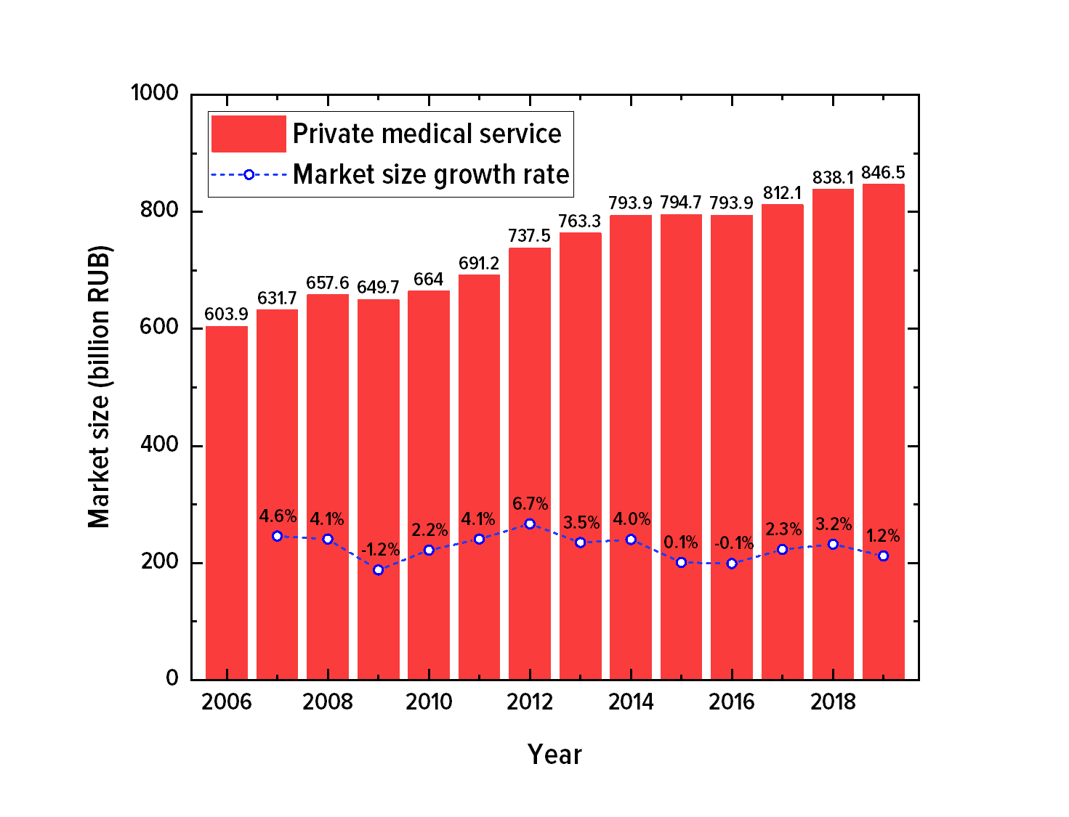
Graph 5. Dynamics of the private medical services market size growth in Russia, 2006-2019, ₽ billion in comparable 2019 prices

Vladimir Putin designated the development of private medicine as one of the goals of state policy in the field of healthcare: “of course, it is important to develop and support private, paid medicine.”
However, the existence of a quality public health system is contrary to the development of paid medicine. No one will apply for an expensive medical "service" if you can get timely and high-quality care for free in a state medical institution. In order for citizens to start turning to private clinics en masse, it is necessary to create a situation in which it is impossible to get help in a state institution, or it will be of inadequate quality. The health care system inherited from the USSR was successfully reduced to a state of inability to meet the needs of the population by the Russian government.

COVID-19 pandemic
Obviously, the collapse of healthcare could not affect the COVID-19 pandemic situation. The coronavirus has become a powerful “stress test” for many healthcare systems around the world, including the Russian one. How did Russia hold this test?
The continuous “optimization” of medicine led to the collapse of the healthcare system during the pandemic, causing significant difficulties for the population in seeking medical help not only for coronavirus but also for other diseases. At the peak of the incidence, the authorities simply cancel the treatment of many diseases, planned hospitalizations and operations due to the overload of the healthcare system.
The monstrous death rate from COVID-19, a surge in mortality due to other diseases, and, as a result, a record population decline since the Great Patriotic War are all the result of the “achievements” of the national “Healthcare” project.
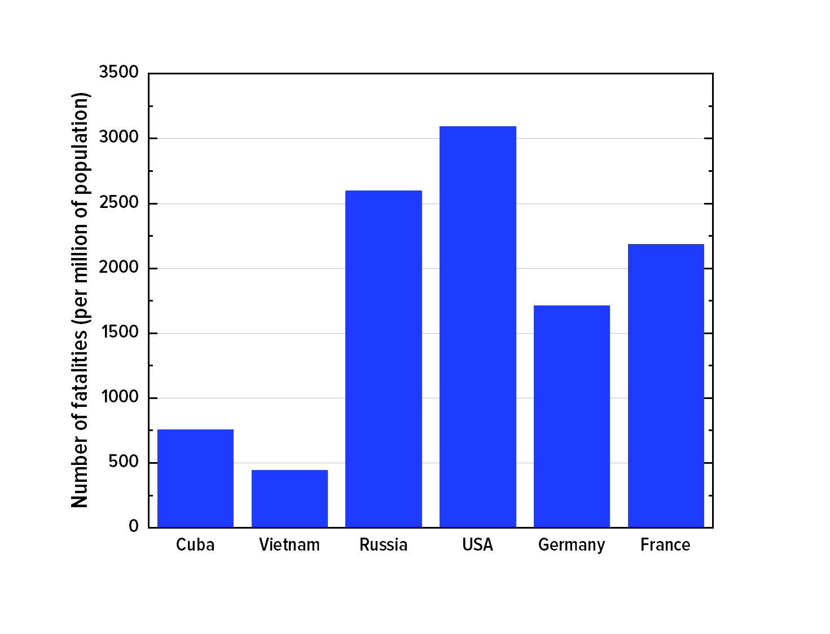
Graph 6. COVID-19 lethality rate per 1 million people

However, Russia does not particularly stand out against the other capitalist countries until September 2021, holding the 22nd position in Bloomberg's rating. However, now the situation is left without control, COVID is "officially defeated", and Russia stays at the end of the list.
The results of the work of the national "Healthcare" project show that its main goal may have been to turn medicine from a funded industry into a profitable one, or at least not require large expenses. The result was a chronic underfunding of the sphere.
You can read more about healthcare under capitalism in our specific article.

Education system
The second priority national project which implementation is necessary for the development of the country, is education, which Vladimir Putin outlined in the national priority projects program:
"We must finally create the foundations for a breakthrough innovative development of the country, to strengthen its competitiveness."
In order to implement the project, it was proposed:
- introduction of innovative educational programs, including distance learning;
- modernization of classrooms, laboratory equipment;
- provide Internet access for educational institutions;
- opening of business schools for the training of managerial personnel;
- "to break the deadlock on the issue of the influx of young people into science";
- an increase in teachers' salaries, a new system of remuneration, which should be based on the quality of teaching;
- additional monthly cash reward for classroom guidance;
- annual incentives in the amount of 100 thousand rubles for 10 thousand of the best teachers in the country.
The national project itself focuses primarily on the technical side of the education quality. Modernization of classrooms and equipment is certainly important, but the basis of education quality is still defined by the teacher. And with this - namely with the Russian teachers' status doesn’t look pretty at all.
Some of the promises to teachers have been fulfilled, for example, an additional monthly wage increase for taking class management has been implemented. It’s amount is 5,000 ruble (around 72$) in 2022.
Other rewards remain questionable. There is no centralized data confirming annual incentive remuneration in the amount of 100 thousand rubles for 10 thousand of the best teachers. There is only scattered information from the regions about competition winners and participants awarding. These numbers suggest that, perhaps, they are much less than 10 thousand teachers are awarded annually:
- Moscow region, 2022 - 100 participants received 100 000 rubles and 51 received 200 000 rubles.
- Irkutsk region, 2022 - 20 laureates for 100 000 rubles.
- Saratov region, 2019 - 15 best teachers received 200 000 rubles
- Zabaikalsky Krai, 2020 - 10 best teachers received 200 000 rubles and 5 received 100 000.
*100 000 RUB is approximately 1 448 USD
200 000 RUB is approximately 2 896 USD
And most importantly, bonuses are always irregular payments. At the same moment the average salary of education workers is 23% less than the average salary level in the country.
The situation around schools and teachers' work overload is bad as well. The number of schools has decreased from 69 to 41 thousand since 2000 which is 43%! The number of teachers has decreased by 38% as well - from 1.75 million to 1.08 million.
Atleast, thanks to “successful demographic policy", the number of students decreased by 21%. This difference with teachers’ decrease in numbers allow us to calculate that workload on schools increased by 31%. One teacher in 2022 had 27% more students in comparison with 2000.
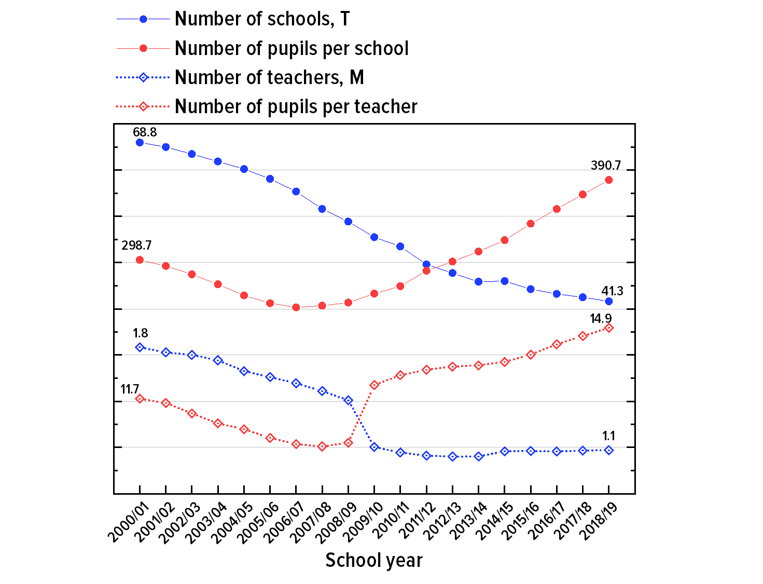
Graph 7. The number of schools and teachers and their workload over the 2000-2019 period.

The situation with higher education is somewhat better. There is a small, but steady increase in the number of budget places in relation to the number of applicants. But things with the scholarship don’t look good. In 2022 the state academic scholarship amounted to 1,500 rubles (around 22$!), which is ten times less than the subsistence minimum.
The decline of the public education quality contributes to the development of the private "educational services" market, which in many ways resembles the situation with the healthcare. According to the data , in 2017 43% of parents of high school students resort to the services of tutors. Entering a prestigious university for popular specialties is extremely difficult without additional paid-for educational services.
Despite the implementation of the national project for many years, the state with education doesn’t look better than with healthcare.

Housing
The third national priority project is the program “Housing”. According to Vladimir Putin’s keynote speech, this program was supposed to fulfill the dreams of millions of Russians, to give what is necessary for a healthy and prosperous family life:
"People's health and their family well-being largely depend on the quality of housing. However, a more comfortable apartment or house, in fact, remains only a dream for millions of Russian families."
To provide millions of Russian families with housing, Vladimir Putin outlined the following tasks:
- achieve significant growth in the volumes of housing construction;
- to provide engineering infrastructure of land plots for housing construction;
- to subsidize mortgage loans;
- to provide military personnel and law enforcement officers with housing;
- to support for young families;
- to restoring order with public transport, housing, communal services and communications fares;
- gasification;
It is noteworthy that the task of providing housing is set only for military personnel and law enforcement officers. Proposed means to solve this problem for other citizens are only housing construction increase and mortgages are proposed.
Housing is provided for military personnel and law enforcement officers, but its method of implementation is especially remarkable – it is done through the "military mortgage" program. it works as follows; an employee purchases housing with a mortgage, and the state pays for it. If you quit after serving less than 20 years, you will have to return everything that the state provided. Thus, the employee is tied to the service for many years, and part of the public funds turns into the profit of the creditor banks.
In the development of the mortgage lending part, the national priority project was certainly implemented, which led to annual records of growth in the creditworthiness of the population and mortgage debt. Since 2019, the average mortgage debt of a Russian family has increased by 76%.
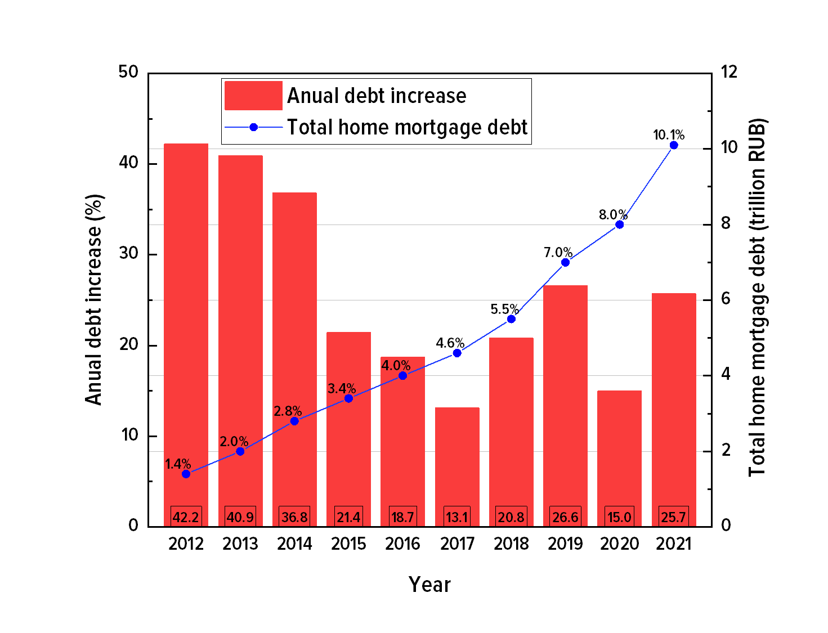
Graph 8. Annual volume and growth of home mortgage debt in the Russian Federation

It is difficult to say what has pushed the development of mortgage lending more: the national priority project or the rise in housing prices resulted in peoples’ inability to purchase housing without getting into debt. The average price of 1 square meter in Russia has grown from 47,500 rubles in 2007 to 75,000 rubles in 2020.
Massive mortgage crediting is an extremely controversial achievement. Lending to citizens only transfers today's problems into the future, aggravating them in the process. In the case of a mortgage, this applies not only to the lenders themselves, but even to their children, who will be born and grow up in housing practically owned by the bank. They even may continue to pay their parents' debts in order not to lose roof over their heads.
So despite the fact that for many years a person has been doing work for society, this exact society being controlled by a capitalist state isn’t able to provide basic needs for its citizens.
Also, mass lending to citizens is harmful for the whole economical system in the long term. By raising demand momentarily, it reduces consumption in the future, puts obstacles to the production development. Future incomes of workers will be redirected into financial bubbles, which despite any support from the state will eventually burst. .
The third national priority project, unlike the first two, promised practically nothing except borrowing plague, and this promise was fulfilled.

III. General state of the economy
In the previous sections, we assessed how the president's promises are being fulfilled and what does the implementation of large-scale national priority projects brings, which according to Russian media tireless media reports are the key to future success. It is worth talking about the general state of the economy of the Russian Federation, to better understand the results of Vladimir Putin's rule.
The economic structure reflects the relationship between all elements of the economy. It allows us to find the main economic driver and how it will be affected by different challenges. And structurally, the Russian economy has a huge bias in the service sector (2018 data):
- agriculture: 3.5 %;
- industry: 26.6 %;
- service sector: 69.9%.
In the industrial production sector, for its part, there is a bias towards the mineral extraction and their initial processing:
27 % — mining;
13.6 % — oil refining;
10.4 % — metallurgy;
5% is another initial treatment.
The service sector is also called intangible production which is the main drawback of this industry. When material difficulties occur - and they regularly do - intangible production is completely helpless. Thus the service sector transforms from From the locomotive of the economy to the driver of living standards degradation and economic recession.
Another important indicator is the state of fixed assets, production assets which are used for a long time. Fixed assets include: buildings, structures, machinery, equipment and devices, computer equipment, tools, vehicles, production and household inventory, working and productive livestock, perennial plantings, etc.
Since the liquidation of the USSR, fixed assets depreciation has increased (the ratio of accumulated depreciation to the total book value) from 35% in 1991 to 49% in 2014. Then the indicator improved, and at the end of 2021, the depreciation degree of fixed assets amounted to 39%. Even taking this decrease of depreciation since 2014 the current figures are quite high. For example, in other BRICS countries, the level of fixed assets depreciation does not exceed 35%. In contrast, mining – the most profitable Russian industry – has the highest depreciation rate: it is more than 57%.
High depreciation of fixed assets threatens long-term and profound problems: reduced productivity, increased operating costs, reduced quality of products, environmental degradation, increased production harmfulness and occupational injuries.
Due to the lack of proper maintenance and renewal of fixed assets, the development of productive forces for decades has been hindered in Russia. The "effective owners", under the patronage of the bourgeois state, squeeze the last juices out of the production means created in the Soviet Union. Their privatization has already led to monstrous natural disasters and human casualties.
The distortions in the economy structure and the high depreciation of fixed assets fit perfectly into Putin's vision of global development:
"I am referring to the rapidly occurring profound changes in the entire mankind way of life, which is associated with the formation of what is commonly called a post-industrial society. Let me remind you of some of its main features.
This is a change in the economic structure of society: the share of material production is decreasing and the share of secondary and tertiary sectors are increasing."
Such Putin’s promises are being successfully fulfilled through all the years of his "rule", as well as:
— "consistent integration of the Russian economy into global economic structures"
— "active state support of foreign economic activity of Russian enterprises"
— "creation of the federal agency for export support"
— "inclusion of Russia into the international regulation system of foreign economic activity, primarily into the WTO"
From the article "Russia at the Turn of the Millennium", dated December 30, 1999.
But the promises of rapid innovative high-tech development, for some reason, are not being implemented.
The development of the Russian economy in this way has created a monstrous import dependence. In 2021, the dependence on food products imports reached 40% and 53% on non—food products. Dependence on cars imports reached 39%, on auto parts — 95%. Dependence on machinery and equipment import reached 58%. Imported medicines and medical products dependance rate is 60%, on clothing the same is 82%, for shoe import the figure is 88%. Computers and electronics import dependence rate is 87%.
In the article "What happened to import substitution", we have already considered ways to resolve import problems due to sanctions. In short, there is an aggravation of import dependence from China which is accompanied by an economic recession due to the increased costs caused by shipments reorientation and transferring production. The costs, of course, will be paid by people who will pay higher prices.
Import dependence is far from being the only problem of the Russian economy. The state of the industry as a whole is unsatisfactory. The number of businesses closing is twice the number of those opening.
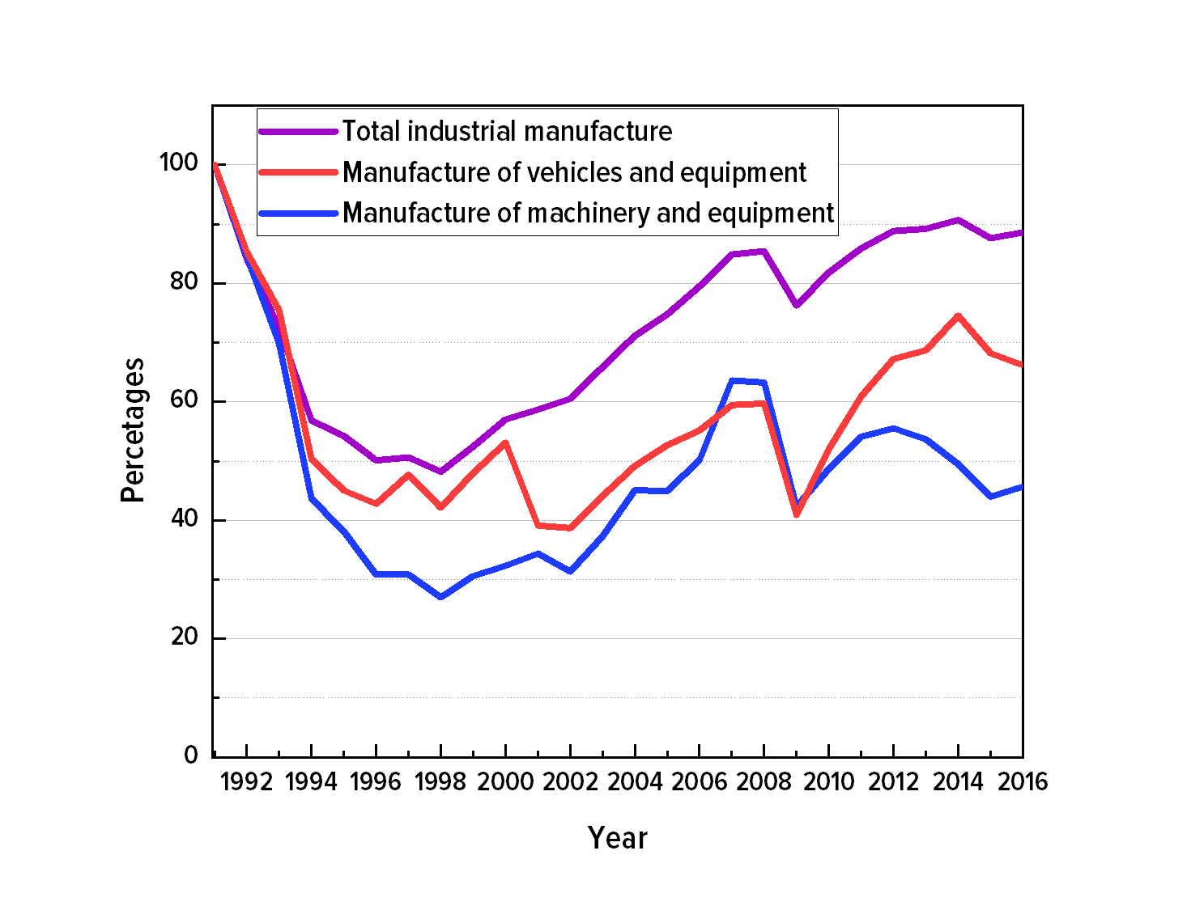
Graph 9. Industrial production level in Russia (%) from 1991
The growth that was outlined at the beginning of the 2000s ended and Russia has not reached the level of 1991 according to the industrial production index both in total production and in the most important industries.
Contrary to all promises and statements to become a powerful economic superpower, the Russian Federation not only did not become one, but also significantly lost the industrial complex inherited from the USSR.

Conclusion
Vladimir Putin 's reign can be divided into two stages:
1. Recovery growth against backed by favorable market conditions;
2. Stagnation, arrest of development and the present period of "stagnation".
Following the "main path of development", Vladimir Putin has brought Russia to a dead end, the decade lacking any growth. While maintaining the previous model of economic development, it is impossible to overcome stagnation.
At the same time, calls are regularly heard from high tribunes to consolidate and rally, which in fact does not change the current capitalist system, but only brings it closer to its extreme form, which promises increased workers exploitation, the collapse of democracy and armed conflicts up to the new World War.
In this article, we have many times mentioned Vladimir Putin, his promises and programs as well as how they are being implemented. We saw little good and a lot of problems, but their nature, the reason for the stagnation is not the personality of the president or the prime minister, but capitalism in its specific Russian conditions. Without abandoning capitalism, Russia will not be able to achieve success and become a prosperous country with a healthy and happy population.
The alternative to capitalism is socialism. The achievements of the Soviet Union only reveal the potential and possibilities of humanity, which has embarked on a truly major path of development. The solution to the problems of Russia and all the global problems of humanity depends on when capitalism will be sent to where it belongs: to the museum of antiquities, next to slavery and feudalism.

Original article

