20,000 Rail Workers Strike in the UK
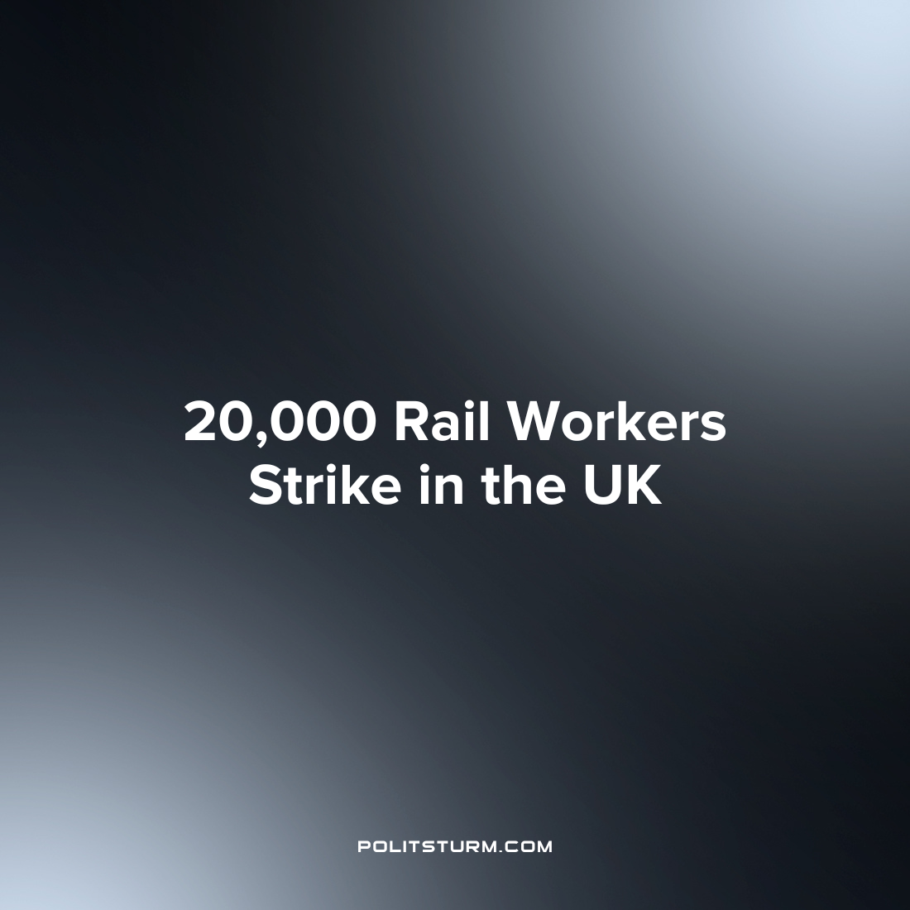

Original article
2023-08-30
2 min read

On August 26th, 20,000 rail workers in the UK went on strike as part of an 18-month ongoing dispute over wages and job security that we have covered previously since the very start. These new strikes had gone ahead due to the fact that a deal was not reached granting an above inflation pay rise as well as safeguarding ticket office jobs earmarked for redundancy measures.
In response to these new strikes a Department for Transport government spokesperson said:
“By cynically targeting the bank holiday weekend, and driving more passengers away from train travel when our railways are already losing £10m a day even without industrial action, the RMT's strikes are damaging its own industry's future”
The British rail minister previously admitted that the strikes cost more than an above inflation pay rise for the rail workers (even going so far as to compensate the rail cartel with equivalent revenue lost on every strike day). It is very clear that the government is not some neutral arbiter between the rail workers and rail cartel, but a tool in the hands of the rail cartel to bludgeon the workers. In fact, the rail cartel are the ones who have made Britain’s railways unreliable and the most expensive in Europe while the government covers their losses, while the workers fight for the industry’s future and their livelihoods within it.
The general secretary of the RMT, Mick Lynch has said:
“Our industrial campaign will continue as long as it takes to get a negotiated settlement, and to save as many ticket offices as possible. RMT members remain committed to winning a pay rise, securing their future employment and maintaining good working conditions. And they have shown tremendous resolve in the face of a government that is playing politics and refusing to do a deal.”
This is in the wake of the majority of striking workers in other sectors accepting below inflation pay deals, leading to the end of the large-scale strike wave. The RMT, being one of the most militant of the currently existing British unions, has chosen to not accept a below inflation deal and fight until the end for its workers. However, even if the RMT succeeds in this struggle its victory will only be temporary as the capitalists will continue to raise the price of goods and drive inflation. For a total victory the workers too must “play politics”. However, trade unions by themselves are only capable of fighting the workers’ struggle in the economic sphere. The workers need to organise a genuinely communist party to influence and direct the struggle in the political sphere.

Sources: 1 2

Original article

