18% of Floridians Have Flood Insurance as Hurricane Ian Ravages State
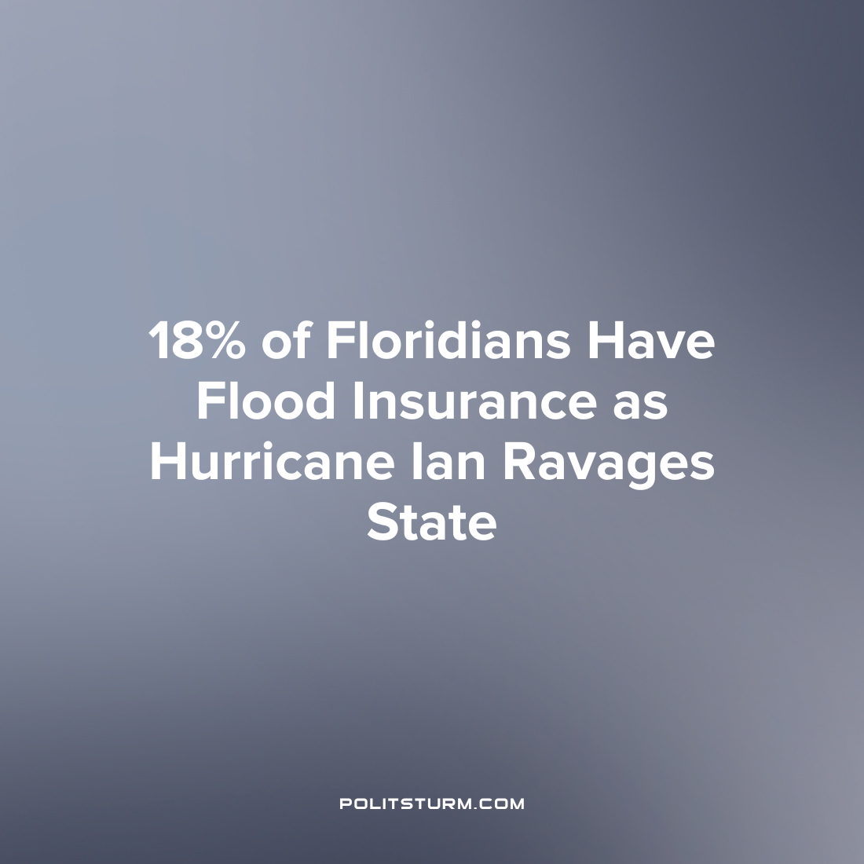

Original article
2022-10-04
1 min read

Hurricane Ian has ravaged the state of Florida, causing billions of dollars worth of damage to homes and other property across the state. However, according to the Insurance Information Institute, just 18% of Floridians have flood insurance and have some form of coverage for any flood-related damage. As the costs to insurance companies to pay out claims for damages have risen, so too have the insurance premiums for flood insurance in the state of Florida. This has led to a decline in the number of individuals and families in the state who have flood coverage despite the obvious risks for hurricane-related flooding in this region of the country.
According to Bloomberg, when the Federal Emergency Management Agency (FEMA) changed its methodology for assessing risk, millions of insurance policies faced rising costs. In the trailing twelve months prior to August 2022, 49,000 Floridians dropped their flood insurance coverage which represents a decrease of 2.9%.
The capitalist economic system handles insurance in an anarchic way where the price mechanism leads to illogical outcomes. For example, natural disasters increase the risk to profit-driven insurance companies who naturally increase their insurance premiums which leads to less individuals carrying policies due to increased costs. While the rich can afford expensive insurance policies and have little concern for these events, those who cannot afford coverage will be faced with the largest costs and burdens in the event of natural disasters.

Source: 1

Original article

