18.2 Million Americans Severely Burdened By Housing Costs
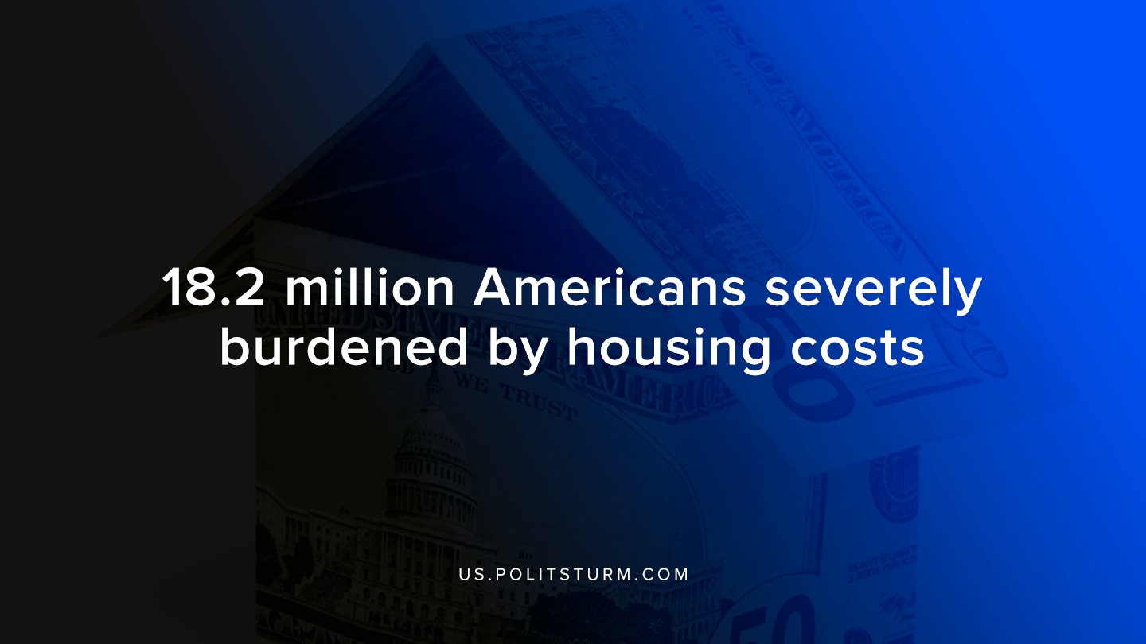

Original article
2019-10-15
1 min read

The Joint Center for Housing Studies at Harvard University conducted a study into the housing markets in the United States. The study examined the state of the U.S housing market and the potential implications of the housing market on the population.
One of the troubling statistics presented by the study was that nearly 18.2 million Americans were severely burdened by housing costs. This means that they pay more than 50% of their incomes just toward housing costs.
Households that spend a high percentage on housing have less to spend on other necessities. The study found that households that are burdened with housing costs spend less on food, healthcare, and transportation.
With respect to the newly constructed housing stock, it is intended for the “higher end of the market”. The study says, “The relative lack of smaller, more affordable new homes suggests that the rising costs of labor, land, and materials make it unprofitable to build for the middle market”.
The drive for profitability is what drives the construction of homes for the wealthy whereas the mass of people faces a shortage of affordable housing. The process of gentrification is merely a description of the housing market under capitalism. It is profitable to produce homes for the wealthy and for the purposes of speculation and investment. However, the mass of working people is deprived of appropriate housing accommodations and pay exorbitant rents to the landlords and real estate investors.
Source

Original article

