12 Million Americans Use Payday Loans Annually
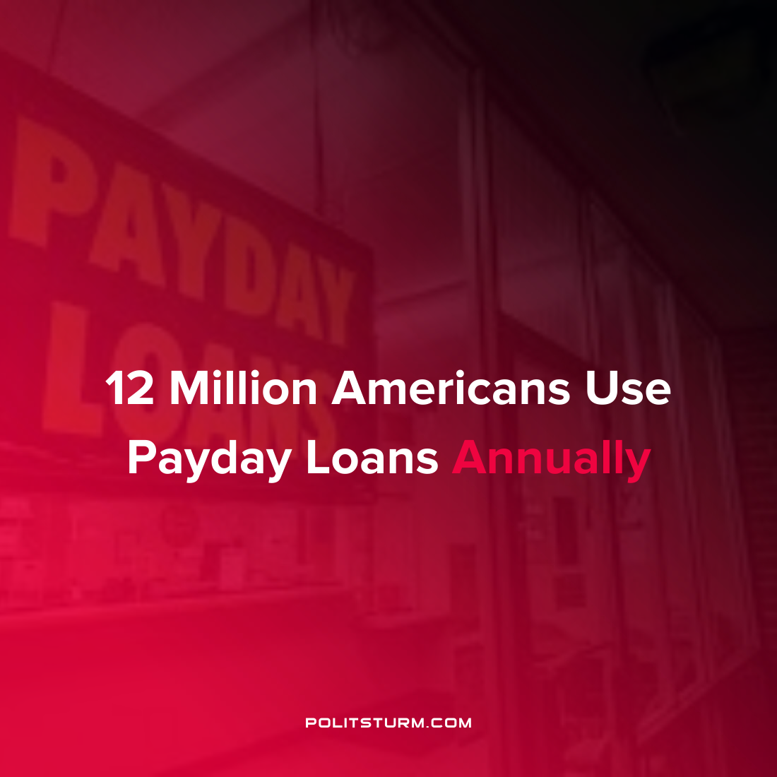

Original article
2022-04-20
1 min read

Approximately 12 million Americans use payday loans on an annual basis and the check cashing and payday loan industry has grown 2.5% every year from 2017-2022. Payday loans are a form of short-term credit which are known to have extremely high interest rates.

The status of Texas has the highest typical interest rate on payday loans at a staggering 664% interest rate. 21 states have no protections on payday loans effectively giving the lenders free reign to operate their businesses and unsurprisingly have extremely high interest rates.

While the payday loan industry tries to portray their operation as providing loans for unexpected events, the majority of loans are taken out to pay recurring, everyday expenses for people living paycheck to paycheck. 69% of first-time payday loans are taken out to meet recurring expenses such as rent or utility bills.

The profitability of payday lenders is dependent on keeping borrowers trapped in a cycle of repeat lending. For example, the state of Washington passed a law which limited borrowers to eight payday loans per year. As a result, the largest payday lender “decided to close an additional 30 centers in the State of Washington where changes in the law there have greatly affected our ability to operate profitably in that state.”

While the interest rates being charged by payday lenders are not technically usurious, this is simply because the laws in many states do not have any restrictions placed on such businesses. These lenders keep the most impoverished Americans in a cycle of debt bondage and allows the capitalist class to profit off the suffering of the most vulnerable in society.
Source: 1

Original article

