100th Anniversary of the Great October Revolution
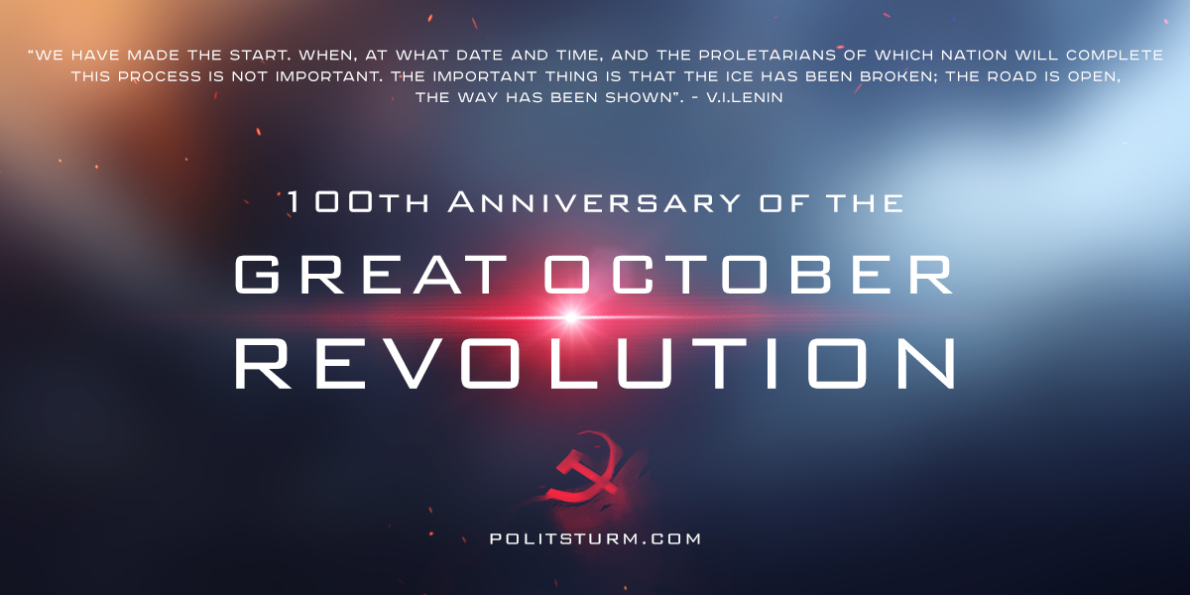

Original article
2017-11-07
1 min read

November 7th marks the 100-year anniversary of the October Revolution which transformed Russia into the world’s first socialist country. On this day the Bolsheviks successfully overthrew the Provisional government to establish the dictatorship of the proletariat. This tremendous victory allowed the new workers’ government to abolish private ownership of the land and give workers control over production. The old machinery of the bourgeois state was dismantled giving rise to the democratically-controlled workers state. This is clearly a remarkable achievement and many lessons can be drawn from this historic event.
However, rather than solely focusing on the past, we must take a sober view of the current economic, political and social conditions in the United States. Our union organizations have been systematically dismantled. Anti-Communist propaganda dominates the mainstream media and has distorted the perception of socialists and workers unions. We have abandoned the science of dialectical materialism and are unable to defend against the weakest reactionary arguments. This has been a conscious effort by the bourgeois class to suppress the working class and inhibit class consciousness. Only through the conscious organization of the working class can we overcome these obstacles and achieve democracy, equality and fraternity. Only through work, organization, and commitment to Marxist principles can we achieve socialism. We must get to work, comrades!

Original article

