1 in 6 Americans Behind on Utility Bills
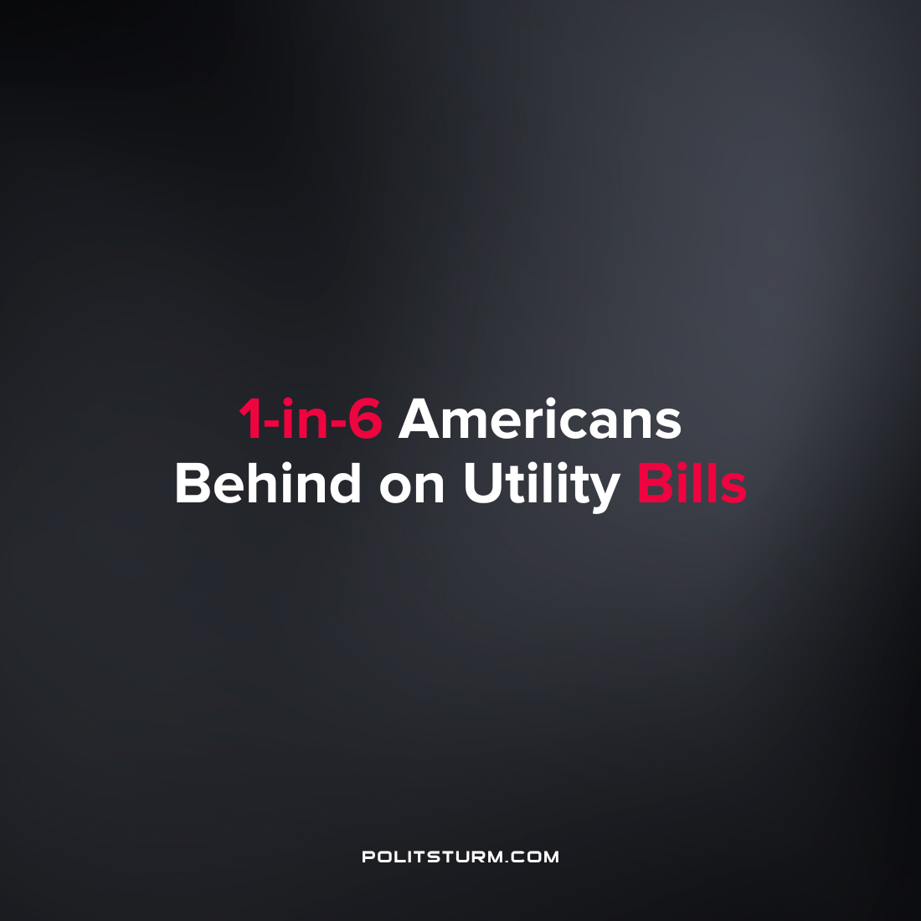

Original article
2022-09-02
1 min read

According to data from the National Energy Assistance Directors Association, 1 in 6 American households are behind on their utility bills. This is the highest figure on record and has been exacerbated by rising energy prices across the country.

Looking at the Bureau of Labor Statistics data on energy prices, average energy prices have risen dramatically over the past year. The price per Kilowatt Hour increased from $0.14 to $0.16 from July 2021 to July 2022.

Error loading image

Source: Bureau of Labor Statistics

These rising prices are putting a strain on millions of Americans who are cutting back on energy consumption in the face of rising prices. Under the capitalist economic system, the workers with the lowest incomes suffer the brunt of the economic fallout from rising prices as the capitalists can simply raise their prices. While millions of American household are strained and burdened by utility debt, the class of oligarchs continue to profit from the current state of affairs.
Source: 1 2

Original article

