1-in-17 Homeless Individuals in California Work in Fast-Food
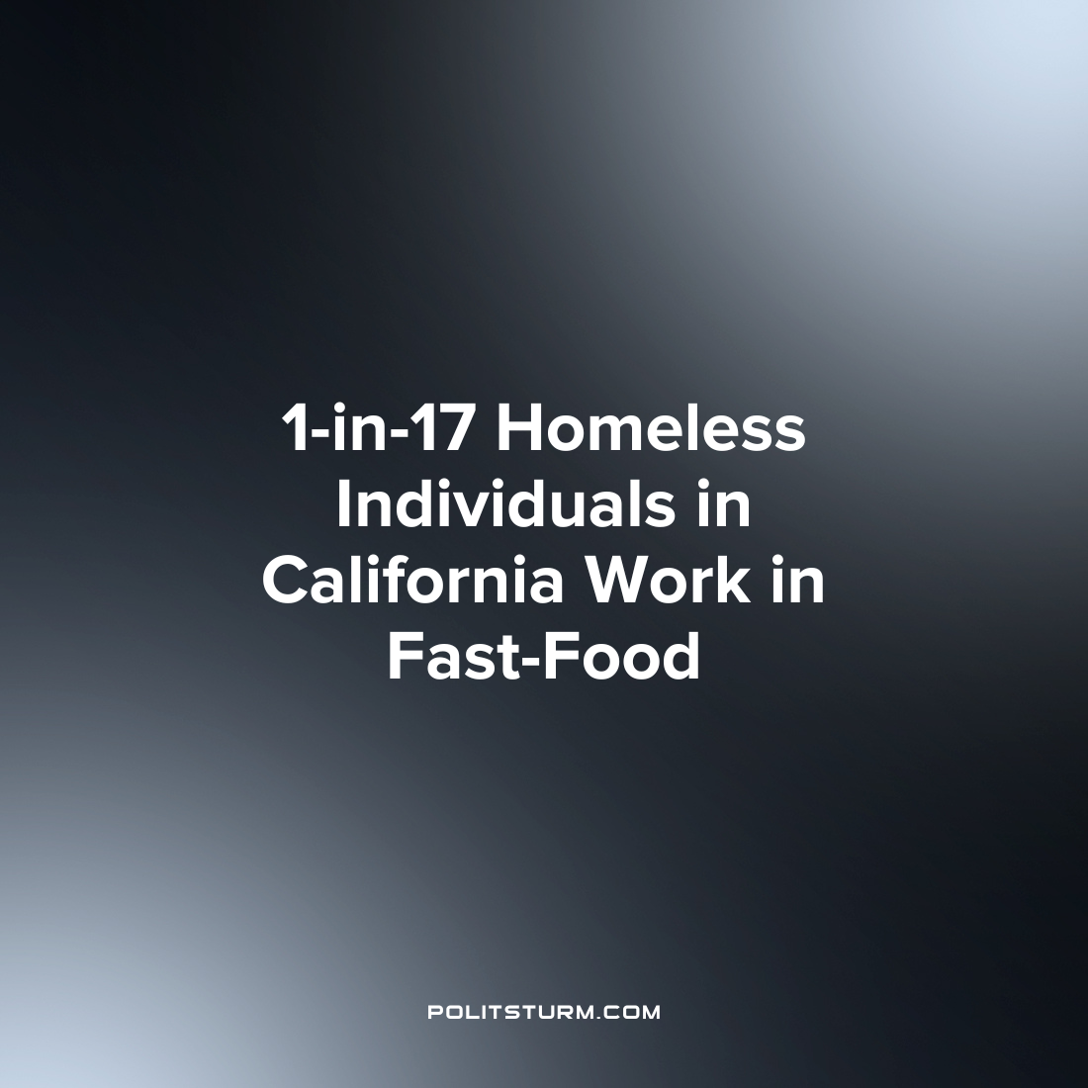

Original article
2023-05-07
1 min read

A recent publication by the Economic Roundtable examined how low wages in the fast-food industry contributed to the disproportional poverty that affects fast-food workers which can lead to homelessness. In the state of California there are 10,120 homeless fast-food workers, which equates to 1 out of 17 homeless individuals working in the fast-food industry. Frontline fast-food workers in California earned annual wages amounting to only $16,800, much less than average of all other industries at $61,858. Two-thirds of California fast food workers earn less than $20,000 per year.
Low wages contribute to the economic insecurity of these workers who are often forced into homelessness due to “unemployment, families breaking up, medical or mental health problems, and substance use disorders”. Low wages and poor benefits often force fast food workers on taxpayer funded government assistance programs such as Medicaid and food stamps which bolsters industry profits. One-third of frontline fast-food workers in the state rely on Medicaid for health care while approximately one-fifth utilize food stamps.
The low wages also force workers to live in overcrowded living conditions. 43% of fast-food workers in Los Angeles lived in overcrowded conditions while approximately 25% paid more than half their income towards rent.
Fast-food companies, owners, and investors were the beneficiaries of these low wages and profit tremendously from these conditions. The top five fast-food companies raked in $14.5 billion in profits in 2021 and $12 billion in 2022. Fast-food companies made $59 dollars for each hour their employees worked.
Whereas the workers suffer from homelessness, housing and food insecurity, and a myriad of other problems the oligarchs profit. The private ownership of the means of production ensures that a small group of owners have a class interest in exploiting their workers to the maximum extent and driving down wages and living conditions to a minimal level. Through this exploitation, the capitalists are able to maximize their profits which they privately appropriate due to their ownership of the means of production.
Source: 1

Original article

