1.5 Million Infected in the U.S.
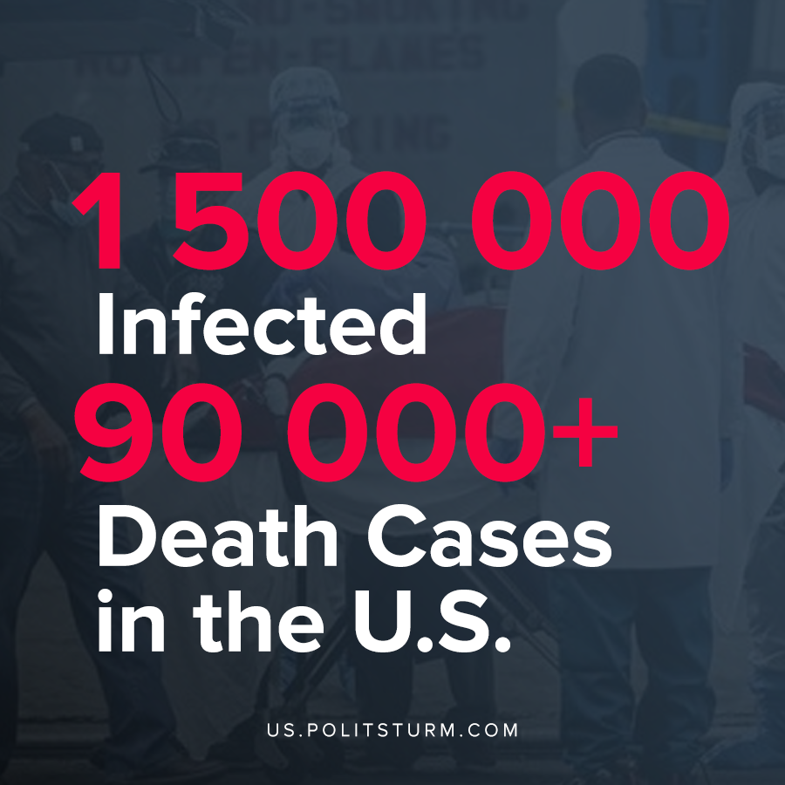

Original article
2020-05-20

Reopened already?

Original article

